Data Protector Demo Guide

Software Version 2019.05 (10.40)

Blueshift Environment Edition

Guide Version 2.5

Document Release Date: June 2019

Legal Notices

Warranty

The only warranties for the products and services are set forth in the express warranty statements accompanying such products and services. Nothing herein should be construed as constituting an additional warranty. The company shall not be liable for technical or editorial errors or omissions contained herein.

The information contained herein is subject to change without notice.

Restricted Rights Legend

Confidential computer software. Valid license or partnership is required for possession, use or copying. Consistent with FAR 12.211 and 12.212, Commercial Computer Software, Computer Software Documentation, and Technical Data for Commercial Items are licensed to the U.S. Government under vendor's standard commercial license.

Trademark Notices

Adobe™ is a trademark of Adobe Systems Incorporated.

VMworld® is a U.S. registered trademarks of VMware.

Microsoft® and Windows® are U.S. registered trademarks of Microsoft Corporation.

Please note, however, the above listing is not all-inclusive and the absence of any mark from this list or the document does not mean it is not trademark. For more detail, on respective names, please cross reference the name on other databases.

|  |  |  |  |
| --- | --- | --- | --- |
| **Date** | **Revision** | **Description** | **Originator** |
| 12/2017 | 2.0 | Data Protector v10.01 | Ted Ayele |
| 7/2018 | 2.1 | Data Protector v10.04 | Keith Walls |
| 10/2018 | 2.2 | Data Protector v10.10 | Keith Walls |
| 1/2019 | 2.3 | Data Protector 2018.11 (v10.20) | Keith Walls |
| 4/2019 | 2.4 | Data Protector 2019.02 (v10.30) | Keith Walls |
| 6/2019 | 2.5 | Data Protector 2019.05 (v10.40) | Keith Walls |
|  |  |  |  |

Table of Contents

Section 1. Getting Started 1

1.1 Introduction 1

Target Audience 1

1.2 BLUESHIFT –Technical Sales Enablement Portal 2

Blueshift Demo Environment 2

1.3 What’s New In This Release 3

Data Protector Features 4

Data Protector Premium 4

Data Protector 2019.05 5

Best-in-class Platform and Cloud Integrations 5

Orchestration, Automation and Monitoring 5

Enterprise Scale and Security 5

Data Protector reports (introduced at DP 10.10) 5

Section 2. The Environment for Data Protector 6

2.1 Environment 7

Environment Diagram 7

Detail 7

2.2 Environment Guide 11

Etiquette 11

Domain User Name 12

Section 3. Demo Outline 13

3.1 Overview 13

3.2 Log in and GUI 13

3.3 Basic Navigation 14

Section 4. Devices – The Backup Target 16

4.1 Overview 16

4.2 Targets 16

4.3 StoreOnce VSA 17

Section 5. Backup and Restore 18

5.0 File System 18

Backup 18

File Backup with Source side Deduplication 26

File Restore 28

5.1 SQL Backup and Restore 32

SQL Backup 32

Restoring a SQL database 37

5.2 Oracle Backup 41

Oracle Backup 41

Oracle Restore 46

5.3 Exchange Backup 48

Exchange Backup 48

Exchange Restore 49

5.4 VMware and VMware GRE 50

Section 6. DP 10.10 (and above) Native Reporting 61

Section 7. The Advanced Scheduler 64

Section 8. ARS- Automated Replication Synchronization 71

# Section 1. Getting Started

## 

## 1.1 Introduction

This Demo Guide is a companion to the Blueshift/CIRRUS Software Demo Portal system that was used on preparing this document. Here is brief overview. Please see the DP340 Course collateral attachments for more details.

**NOTE:** The technical details related to the use of Data Protector Software is beyond the scope of this document. The Data Protector software User Guide or Data Protector Course 310 will clarify any specific needs.

### Target Audience

This guide is intended for Data Protector Pre-Sales and Partners performing Data Protector Demonstrations. The guide and the environment assumes the user at minimum completed Data Protector Course 310 and 320. At the very best, the user has completed the courses and read and understood Data Protector User Guide and have knowledge of VMware® and Microsoft Hyper-V® and basic Networking and StoreOnce VSA.

## 1.2 BLUESHIFT –Technical Sales Enablement Portal

This Demo Guide is a companion to the Blueshift Software Demo Portal system that was used in preparing this document. Below provides a brief overview of Blueshift.

### Blueshift Demo Environment

**What is Blueshift?**

* A Hub-and-Spoke hybrid cloud platform where content is managed at the hub and synchronized and made available for provisioning across spokes.
* Utilized for customer-facing demonstrations and technical sales enablement, as well as proof-of-concept support.
* Implemented within a private cloud tenant, which functions as a primary master library and burst provisioning pool.
* A distributed design using private cloud resources as primary provisioning pool for localized usage (Partners, Geos, etc.)
* A single location where all demo assets can be requested and delivered

**Who can use Blueshift?**

* Primary users are internal pre-sales who are part of the organizations with custom access level agreements, allowing for full exclusive demo provisioning ability (Primary Funding Source & Resource Contributor).
* Partners. General access to downloadable assets/literature is available to all approved partners, as well as custom demo access based on financial and business agreement.
* Select downloadable assets may potentially be accessible to the general public. (Still being investigated.)

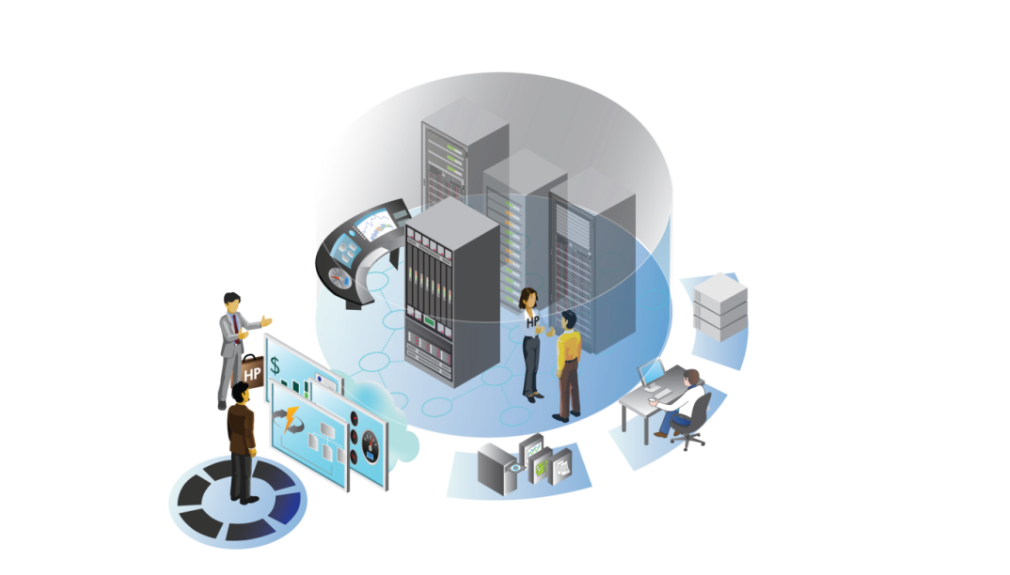

Manage & Monitor/Respond to Unexpected Events

Request Demos

Create/Publish Service

Provision Demos

Release Resources to the Pool

Build New Demos

Customize and Expand Demo Use Case

Present Demos

# 

## 1.3 What’s New In This Release

This section provides a brief description of the key features that are introduced in the Data Protector 2019.05 (DP 10.40) release.

This demo environment only covers Data Protector Premium.

## Data Protector Features

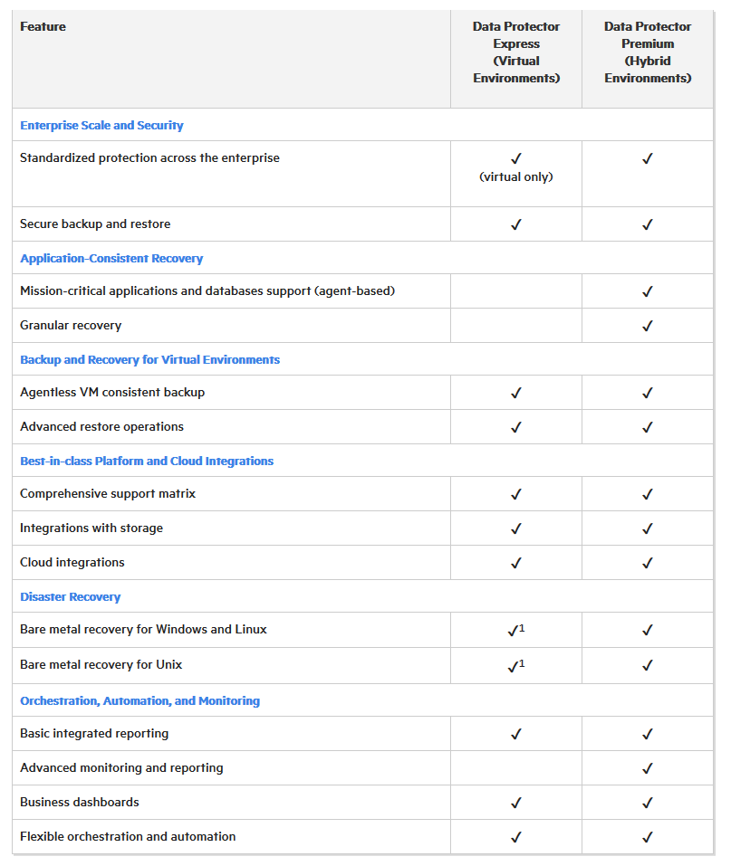

## Data Protector Premium

Data Protector Premium licensing is based on the amount of capacity being protected. If you install Data Protector Express and Data Protector Premium licenses, only the Data Protector Premium license is used.

## Data Protector 2019.05

**Data Protector 2019.05 highlights include:**

### Best-in-class Platform and Cloud Integrations

* **Zero Downtime Backup (ZDB) for NetApp SnapMirror** with ONTAP 9.x enables Data Protector to leverage array-based replication to back up filesystems and SQL, VMware and Oracle databases providing fast and efficient backups for both primary and secondary NetApp storage systems
* **Comprehensive support matrix: Support for IBM PowerPC for SAP HANA** enables Data Protector to back up and recover IBM PowerPC servers deployed with SAP HANA solutions for SLES and RHEL environments
* **Comprehensive support matrix: Support for PostgreSQL clustering** allows users to back up and restore multi-master high-availability clusters in PostgreSQL environments

### Orchestration, Automation and Monitoring

* **Advanced Reporting and Analytics:** Enhanced integrated reporting provides support for Ubuntu for reporting server installations. Furthermore, detailed problem description and recommended actions for a substantial number of DP errors provides faster discovery of root causes for backup failures, leading to quicker resolutions.
* **Advanced Reporting and Analytics:** **Backup Navigator 2019.05** adds support for Data Protector 2019.05 as well as provides enhanced performance and scalability improvements around data collections to improve user experience

### Enterprise Scale and Security

* **Secure backup and restore**: Improved security as a result of white hat penetration testing and National Information Assurance Partnership (NIAP) pre-check testing
* **Enterprise Scale:** Response times improvements for the Web-based Graphical User Experience (GUI) by changing from IE to Chromium provides a better user experience

## Data Protector reports (introduced at DP 10.10)

Data Protector now offers various reports that help you in managing and planning your backup environment. These reports can be accessed using the **Home** context > **Reports** option in the Data Protector GUI. The Data Protector reports are customizable and provide information on the status of the last backup, object copy, object consolidation, or object verification, consumption of media in media pools, status of devices, etc. You can download these reports in PDF, PNG, CSV, or JSON format. You can also configure to send these reports through email in the **Reports** > **Advanced Settings** option. To use the reporting capability, install the Reports component on a Linux or Windows server that is not a Data Protector Cell Manager. The Data Protector reports are available with Capacity, Trial (Express), or Trial (Premium) license only.

Keep in mind that you can ALWAYS find the latest DP documentation on the Micro Focus ITOM Practitioner portal:

[**https://docs.microfocus.com/itom/Data_Protector:2019.05/Home**](https://docs.microfocus.com/itom/Data_Protector:2019.05/Home)

# Section 2. The Environment for Data Protector

The Data Protector instance you are working with here consists of seven Windows 2012 R2 servers running in KVM in CIRRUS, and some VMware VMs running 12 StoreOnce VSA instances as well as some VMware virtual machines. Details on the BLUESHIFT environment are in the release notes that were provided in the accompanying course to this document. The new Data Protector Reporting Server runs on the Domain Controller (probably would NOT in a customer environment.)

## 

## 2.1 Environment

### Environment Diagram

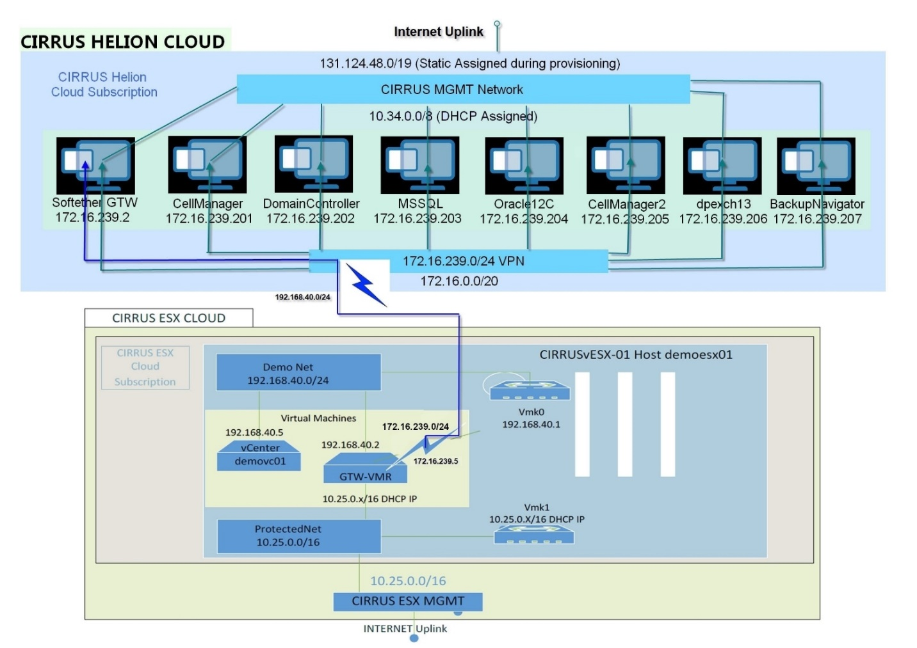

### Detail

We have added an ESXi environment to the standard DP Demo Environment. The new offering consists of seven Windows 2012 R2 servers running in KVM in CIRRUS. The vESX is provisioned in the Cirrus ESX Cluster making this is a Hybrid Cloud Offering. The networking is part of the provisioning making this a seamless experience for the end user.

Note that while your Data Protector and VMware environment is ***exclusive*** to you, the HPE StoreOnce VSA (virtual deduplicating backup appliances) are NOT and they are shared.

To enable a full class of people (or many independent users) to use this system and not overload any one HPE StoreOnce VSA, which will be your backup target for some of the demo tasks, we are asking users to pick as their backup targets the VSA that is assigned to them. In a large instructor-led classroom environment, you may be assigned a StoreOnce instance different from what is listed below.

Simply type <https://10.25.3.x> where x is the IP address shown below.

Here are the assignments:

**YOUR LAST NAME BEGINS WITH USE StoreOnce VSA #**

A B C J StoreOnce VSA #1 (10.25.3.50)

D E F G W StoreOnce VSA #2 (10.25.3.51)

H I K L N StoreOnce VSA #3 (10.25.3.52)

M O P Q V Z StoreOnce VSA #4 (10.25.3.53)

R S T U X Y StoreOnce VSA #5 (10.25.3.54)

Replication Target StoreOnce VSA #6 (10.25.3.55)

These devices will be pre-populated on the DEVICE tab of Data Protector. Simply choose this device when performing a backup to the StoreOnce. Backups to the local Smart Cache don’t have this limitation since each user has his/her own.

**NOTE:** Throughout this guide we have screen shots. This screen shots may not be exactly as you see here, but it will be close. Since this environment is cloud-based and is shared, not everything can be demonstrated.

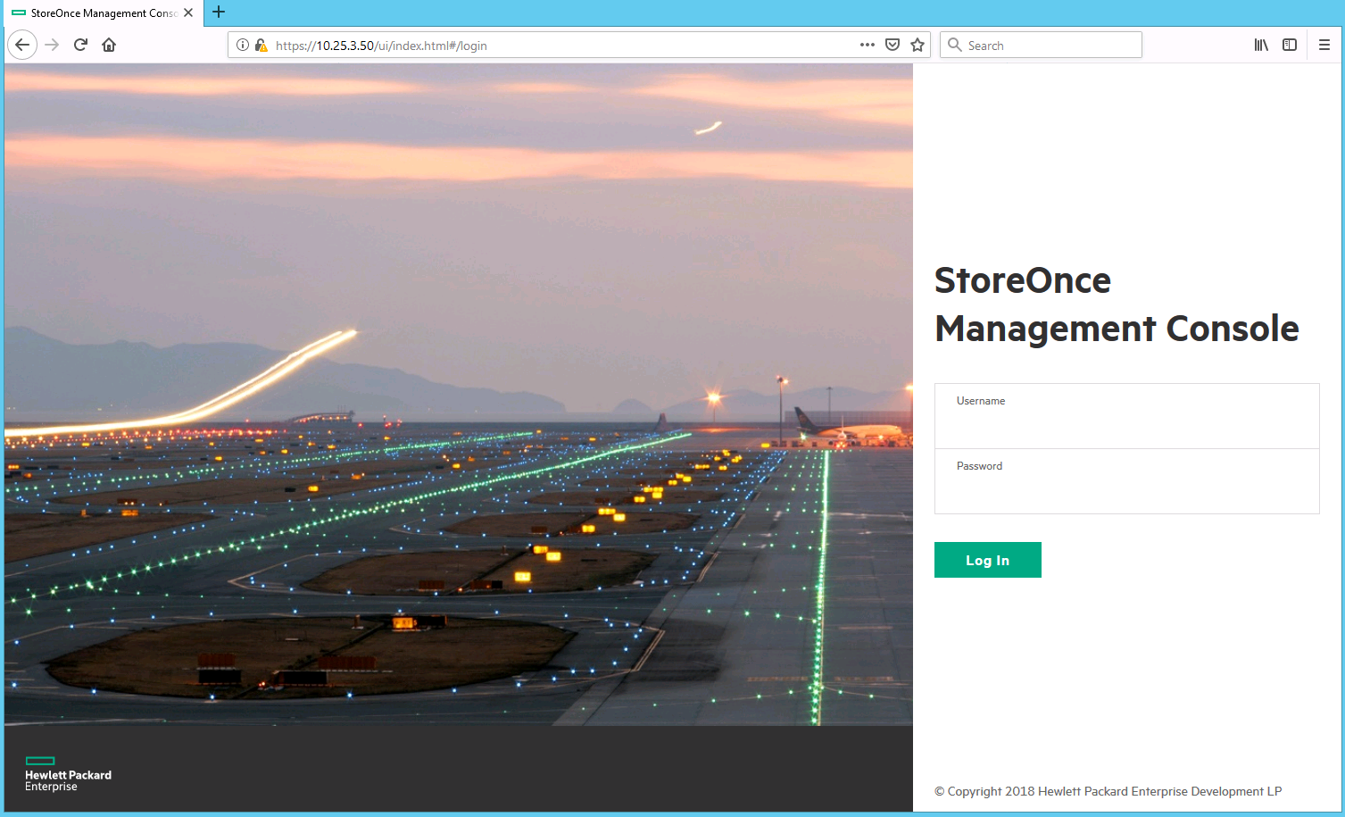

The Username is **Admin**, Password is **storeonce**

You will now see this:

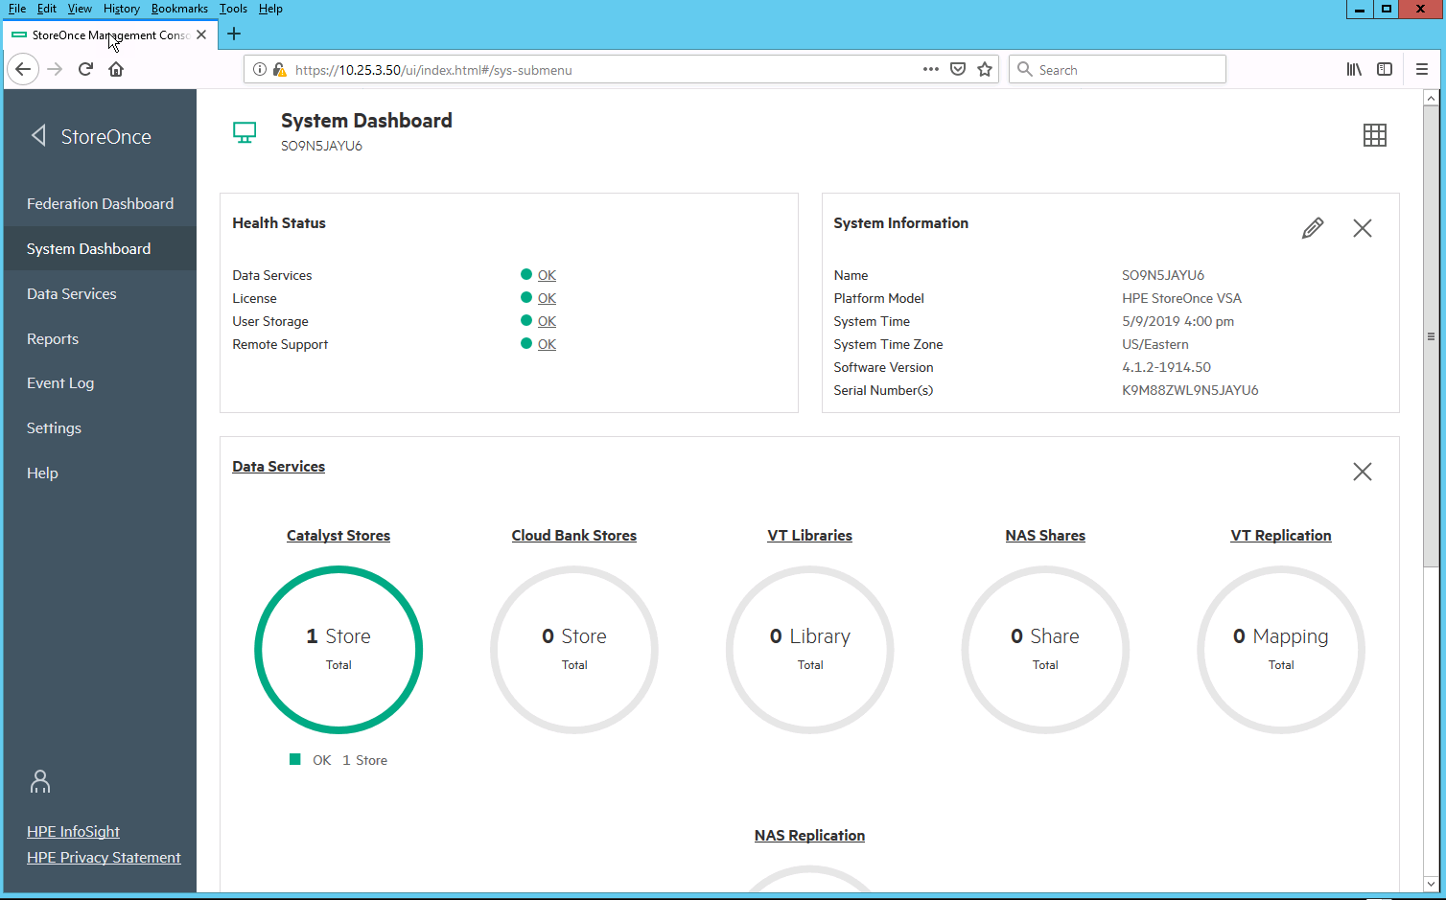

Note that there is one store created. Please do not create any stores on these devices. They are ***persistent*** and ***shared***, and do have limited disk space.

If you go into the **Reports,** you will see this:

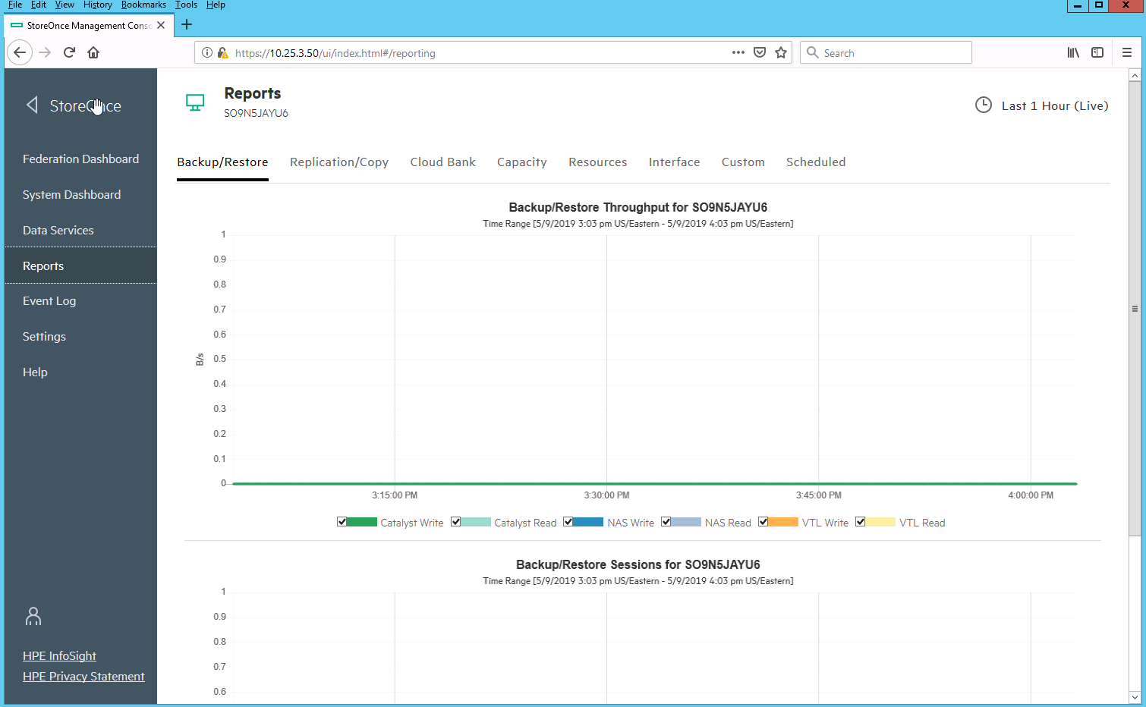

You will likely want to minimize this screen and come back to it while a backup is running.

## 2.2 Environment Guide

### Etiquette

* As it will be outlined below never change the original name of the machine in the VMware side. As well as never change the static IP and name of any server.
* If a new backup task to the VSA is created, then backup target folder should list the name of the server and date and the user initial.
  + For example: If the new task is to backup EXCH13. Then the task folder should be EXCH13_Month_2017_User Initial.
* If a restore is performed to VSA, make sure to rename the Server with restore and the original server name and date and the user initial.
  + For example: If the new server is EXCH13. Then the restored server on the VMworld® side should be Restore_EXCH_Month_2017_User Initial.

### Domain User Name

These user profile is created to demo granular mail restore for users.

**IMPORTANT!** NEVER change the usernames and passwords. You can, however, create a new user name and password.

Full Name: **Ted Mosby**

Username: **Mosby@mfocus.com**

Password: **Nine_Seasons#2005**

Full Name: **Robin Scherbatsky**

Username: **Smulders@mfocus.com**

Password: **Barney#2030**

Full Name: **Barney Stinson**

Username: **Stinson@mfocus.com**

Password: 2030#Scherbatsky

Full Name: **Lily Aldrin**

Username: **Aldrin@mfocus.com**

Password: **Art#2013**

Full Name: **Marshall Eriksen**

Username: **Eriksen@mfocus.com**

Password: **Lawyer@2005**

**IMPORTANT:**

Sometimes in this environment, the Data Protector services do not start correctly. This is a side effect of this environment not a defect in Data Protector. If you get an error message about there not being any licenses available, simply open a command prompt on Cell Manager 1 and issue the following command:

omnisv –restart

When that command completes, restart the GUI, and everything should work just fine.

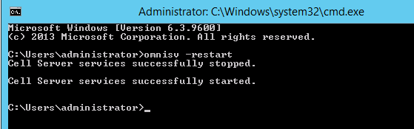

# Section 3. Demo Outline

## 3.1 Overview

Connect to the Cell Manager by RDP into the cell manager using the tab in the email you got with your environment instance.

## 3.2 Log in and GUI

The login is MFOCUS\administrator and the password is DP_Admin123!

There are multiple ways to start the GUI by clicking the below icons.

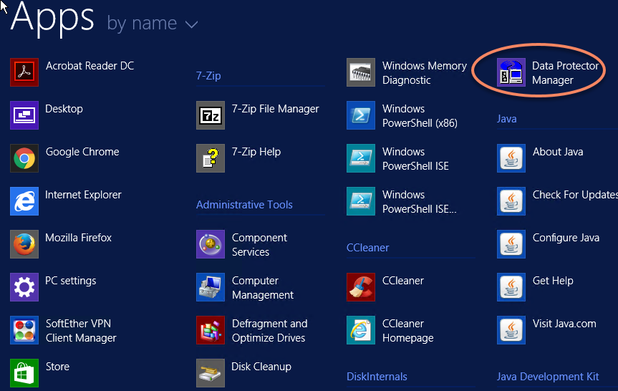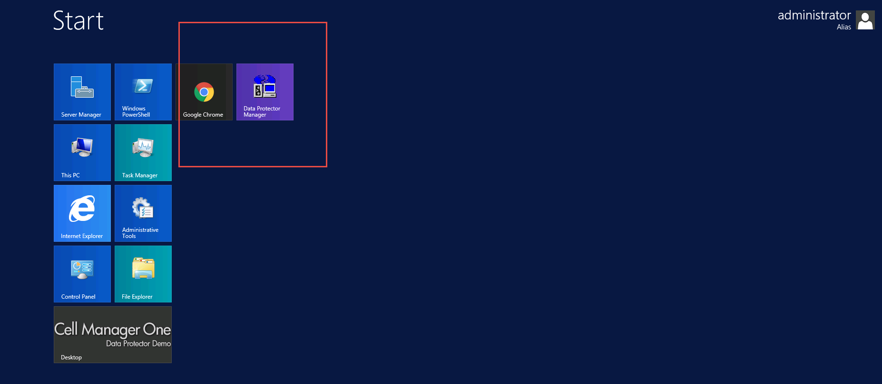

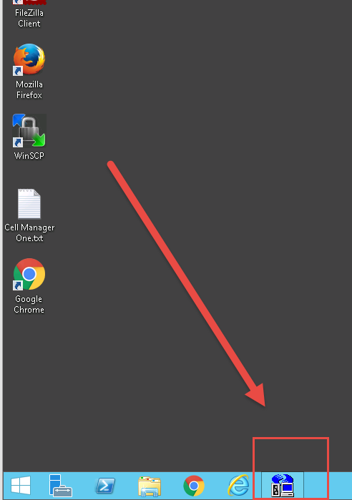

## 3.3 Basic Navigation

Once Data Protector is running click on Context pane– this is where an item is selected for navigation.

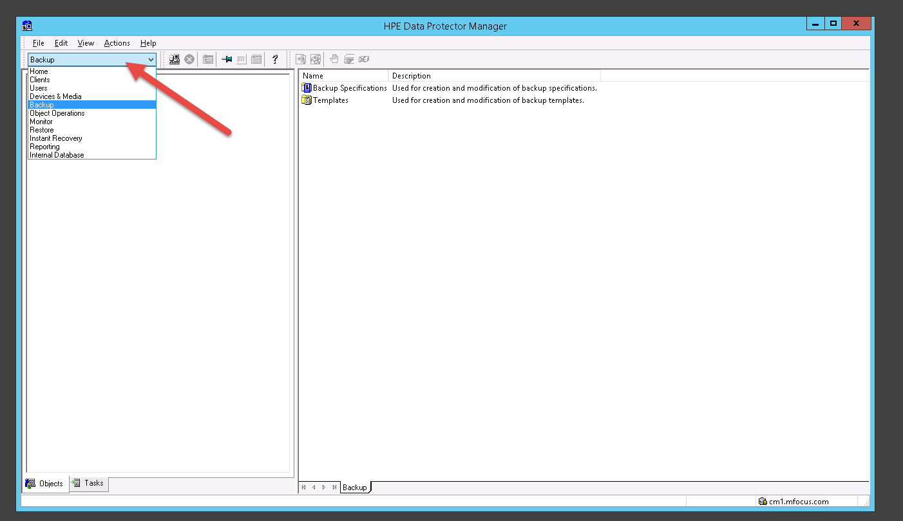

1. 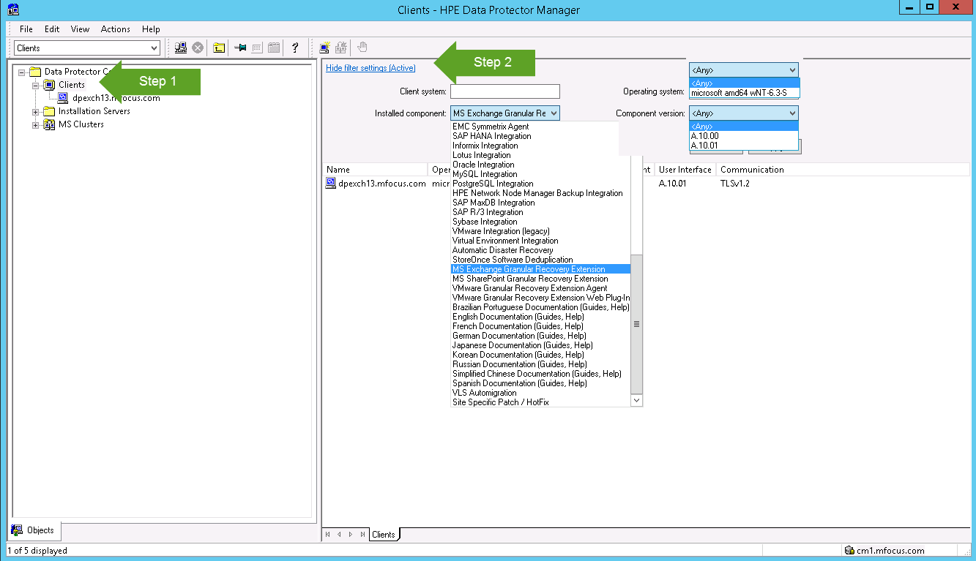Select the Clients context and show the existing clients – click on the show filter settings. This allow to select client system, installed Component on Clients or filter on Operating system level or Component Version.
2. Select a server and right click to show how to add components or upgrade the agent on a server

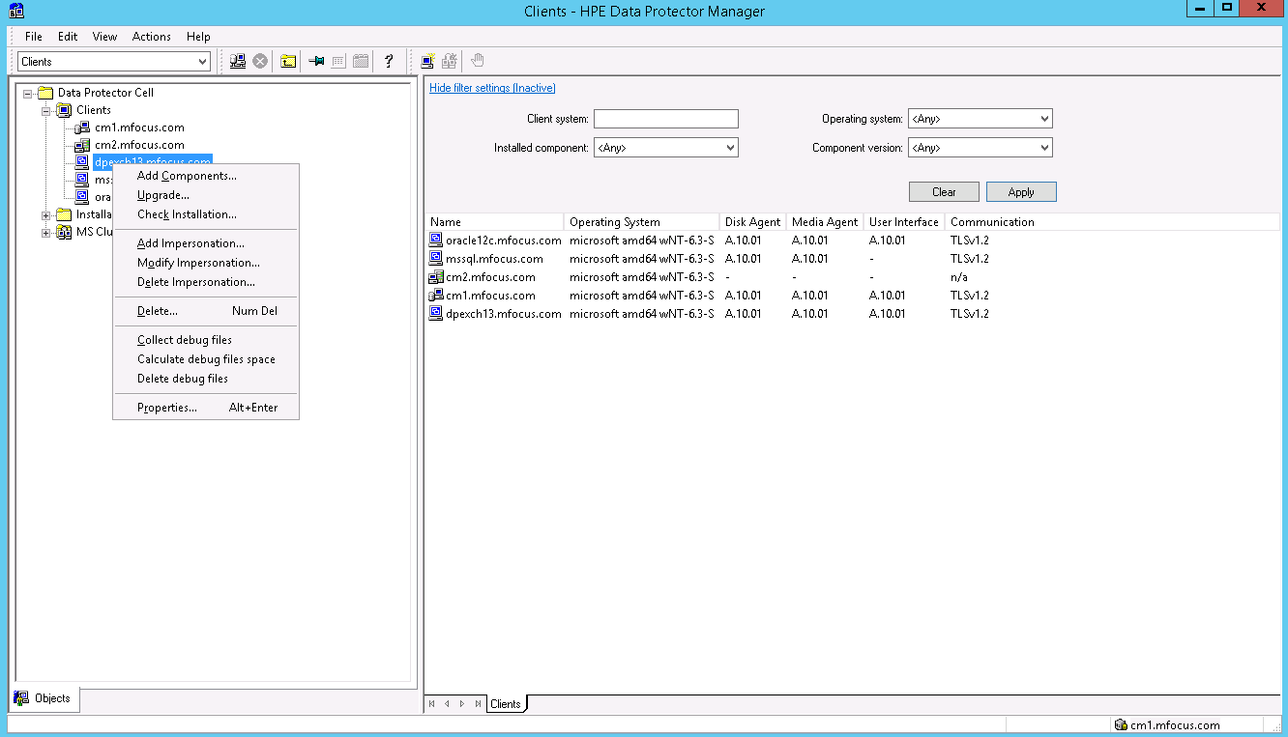

1. Show the installation server – this is a depot where all of the agents are stored and updated before deployment to the servers.

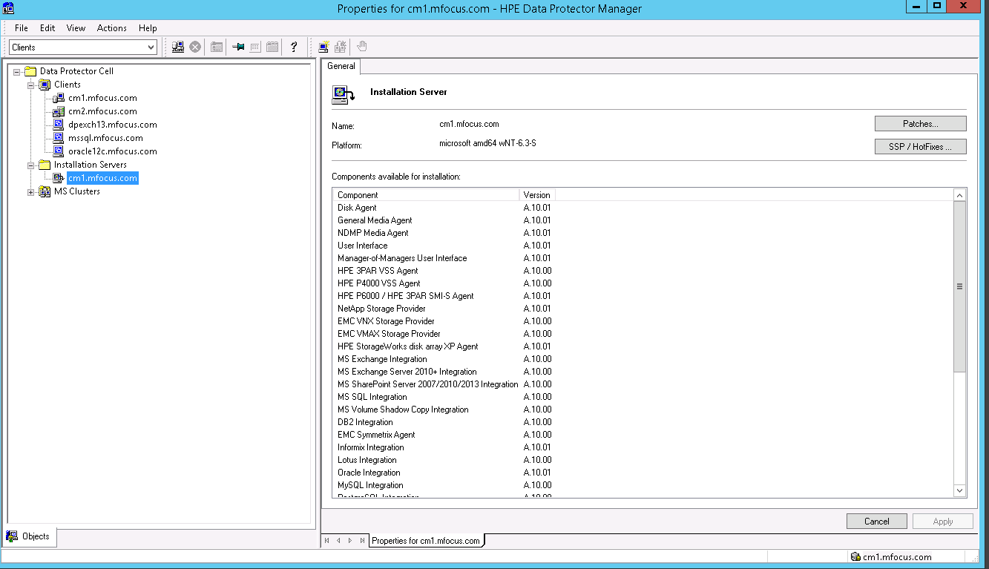

# Section 4. Devices – The Backup Target

## 4.1 Overview

The Demo platform has been configured with two different types of devices for backup target, Smart Cache and the 5 StoreOnce VSAs (deduplicating Purpose Built Virtual Backup Appliance). Since StoreOnce Catalyst gives the most flexibility in demo situations, that is what we will show in this guide. You will also have full access to the StoreOnce VSAs should you want to demo that part to a customer. Since these are persistent and shared by everybody, we ask that you do not create new NAS shares or VTLs on the StoreOnce virtual devices, or if you do, delete them when done. The Catalyst stores required for the demo have been pre-configured as we will see shortly.

## 4.2 Targets

1. Go to the Devices context and Data Protector will show the configured devices

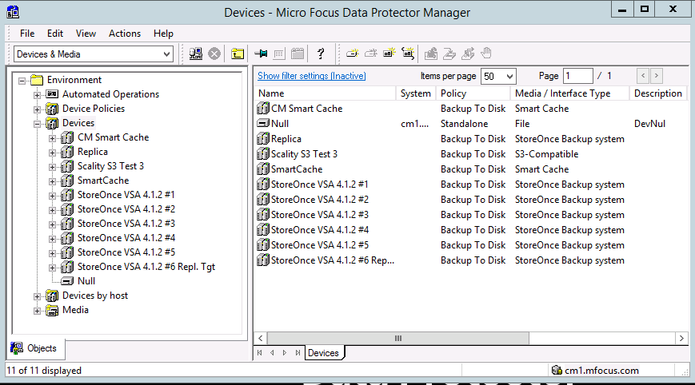

## 4.3 StoreOnce VSA

Please see Section 2 above.

# Section 5. Backup and Restore

## 5.0 File System

### Backup

1. Go to the Backup Context and right click on Filesystem to add a backup

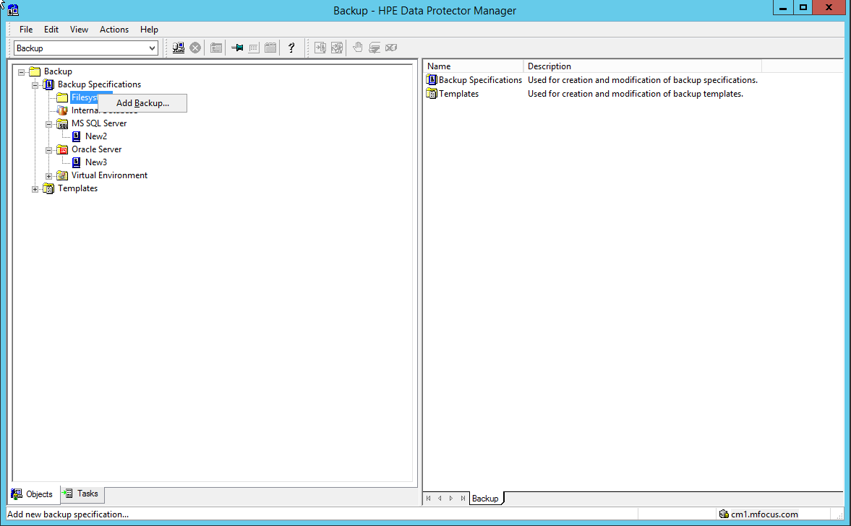

1. When creating a backup you can choose from templates that will prepopulate some of the information that you’d normally have to put in (like schedules). Choose the Blank filesystem backup. Note that at the bottom of the screen we can select source side deduplication. For now, we won’t do source side deduplication.

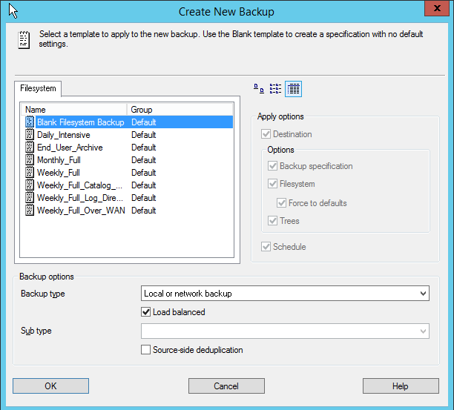

1. Expand out the cell manager server

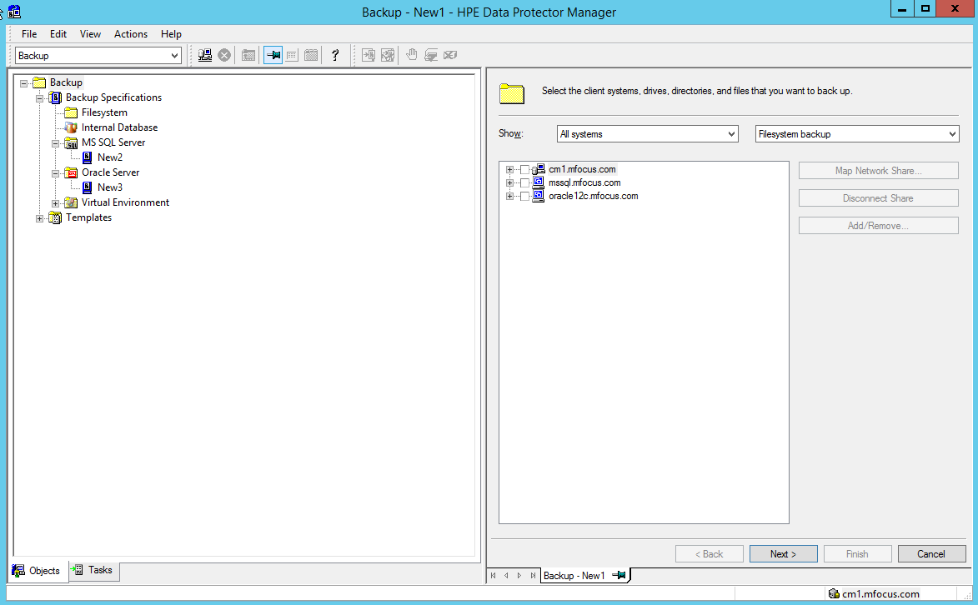

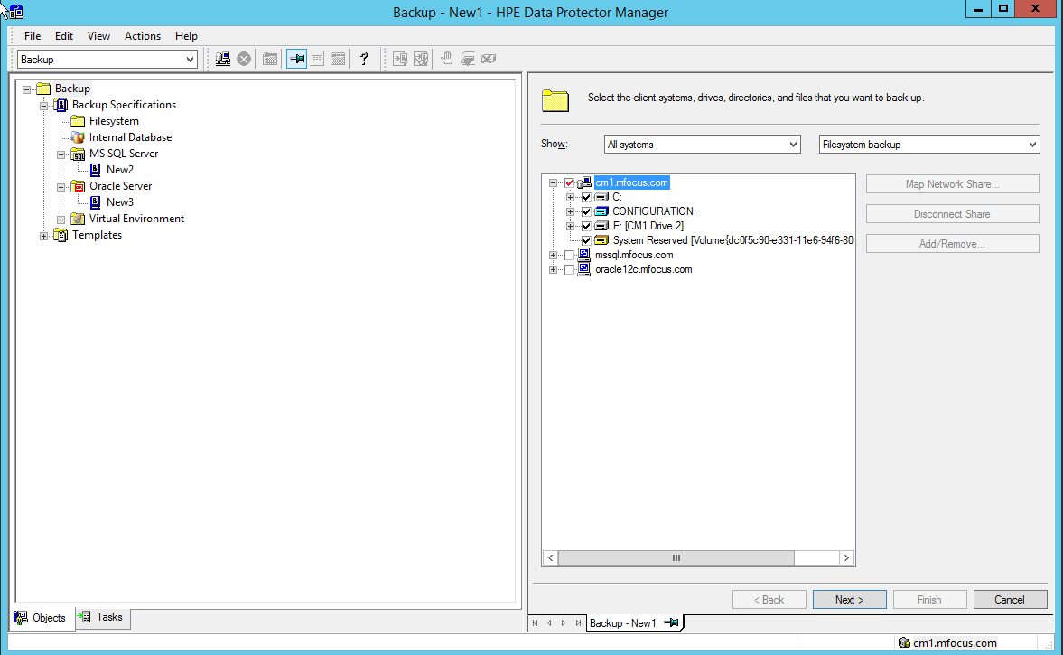

Note that there are different components you can backup up. There’s also the C: drive (which we can further expand), CONFIGURATION which is all of the Windows Configuration information like Registry etc., and a special Windows 2008 hidden drive. To do Bare Metal Recovery for a server we need to back up all 3 of these.

1. Expand out the C: drive and select the Back-me-up directory. This contains just a few files so that you can actually back it up and it won’t take forever.

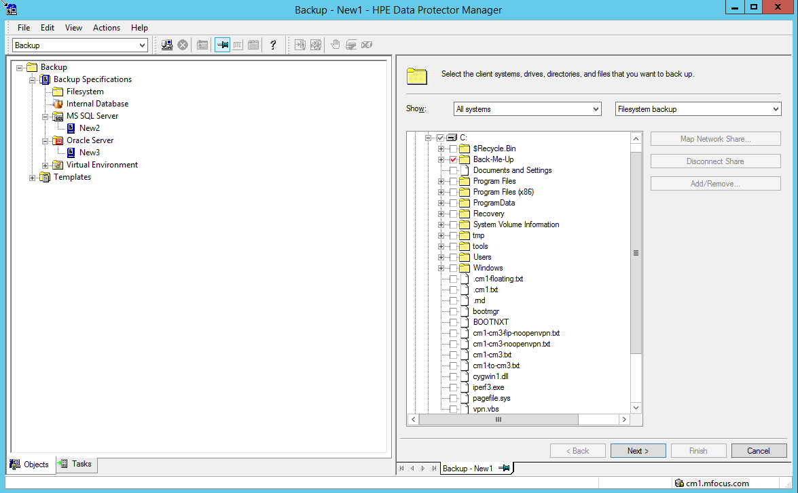

1. For this backup we could select any of the devices. If we were doing source side deduplication that wouldn’t be the case.

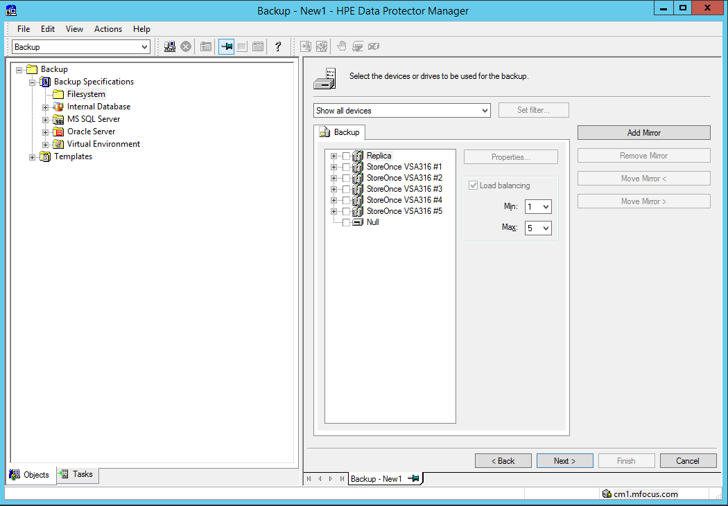

On the next screen we can select a number of options: the most common ones are in the middle section: first the protection – or retention – for the backup.

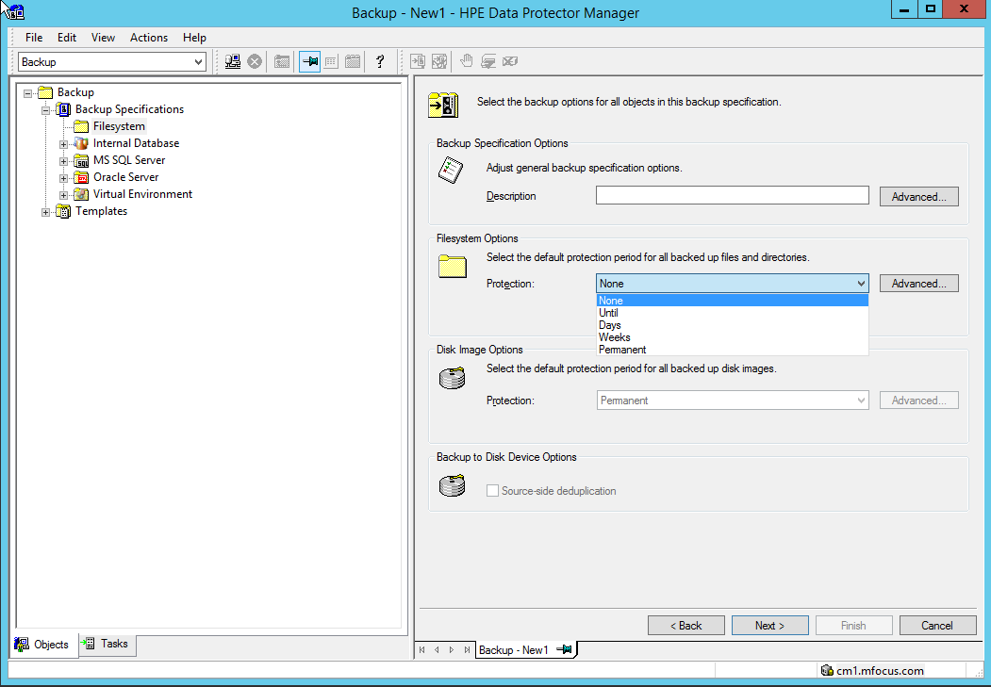

Choose “None” for the purposes of this demo.

And under the Advanced Tab there are more options – the most important of these are:

Enhanced incremental backups – used for creating synthetic full backups

Use change log – speeds up incremental backups

Software compression – to minimize LAN traffic

Display statistical info

Copy full DR image to disk – to assist in being able to quickly create a bootable image for Bare Metal Recovery

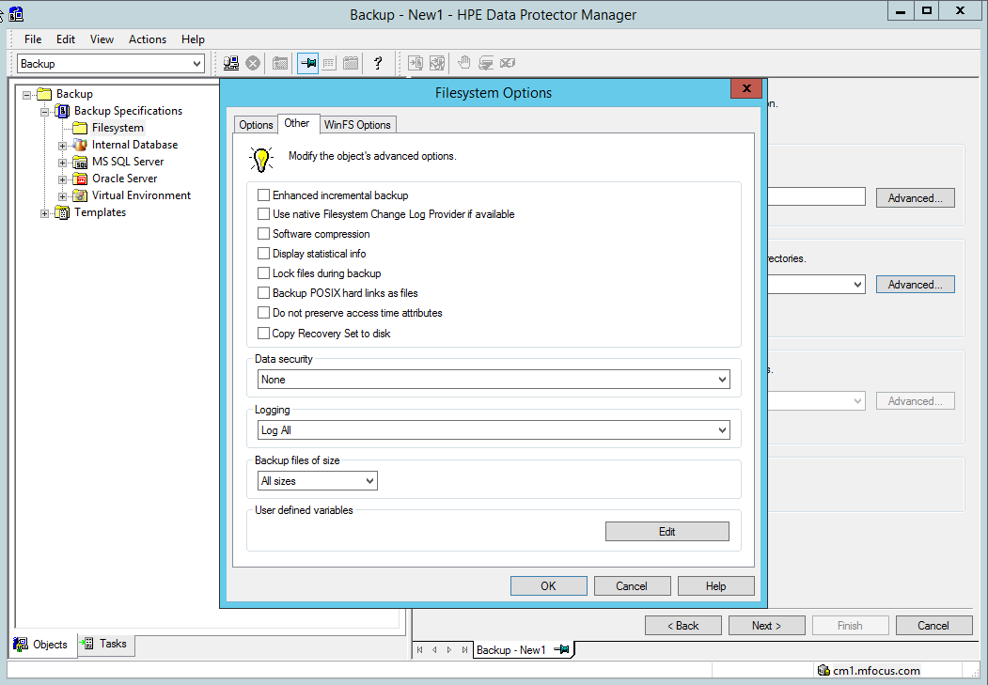

This is an excellent opportunity to show Data Protector Context sensitive help. Clicking on help will allow you to show how this works.

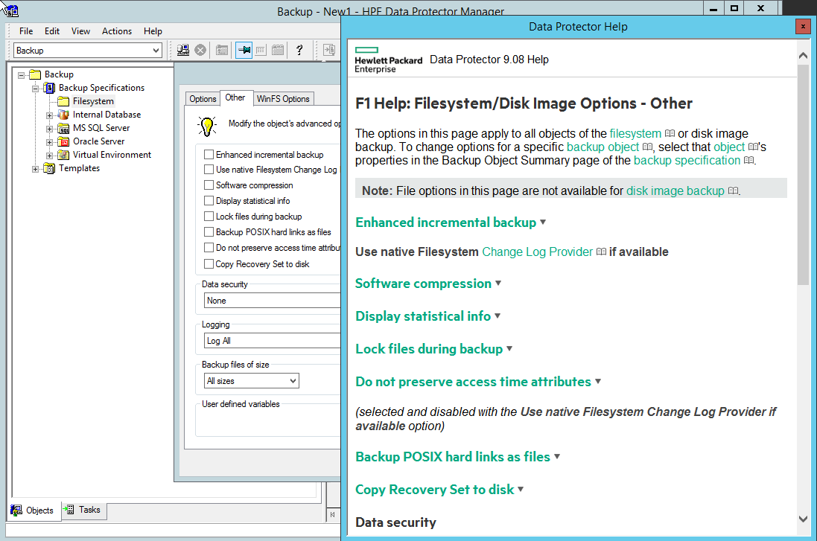

Set the Protection to one week and hit “Next”

At this point we can set a schedule – predefined or manually

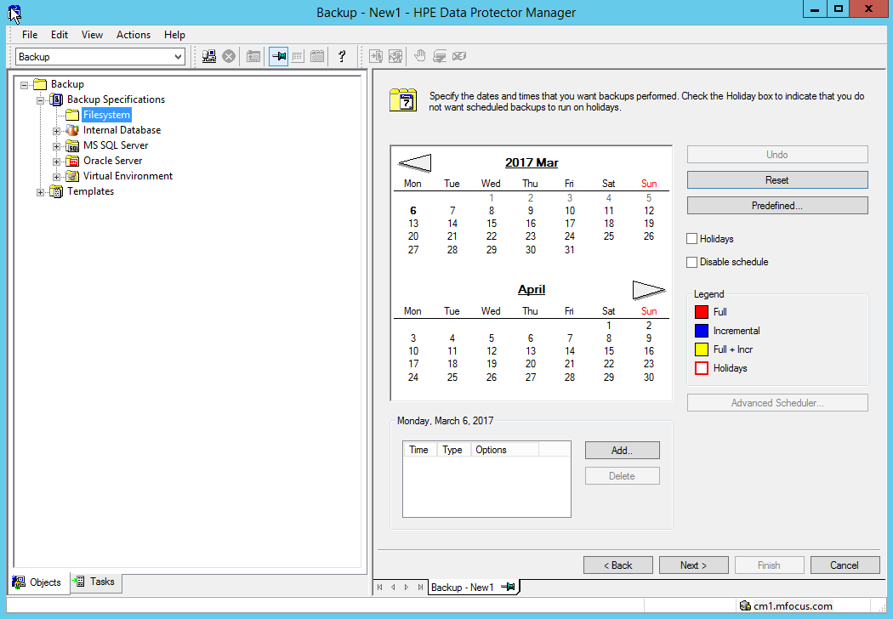

Click “Next” twice and now you can save the backup specification, run it interactively or preview.

You will get a window that looks like this:

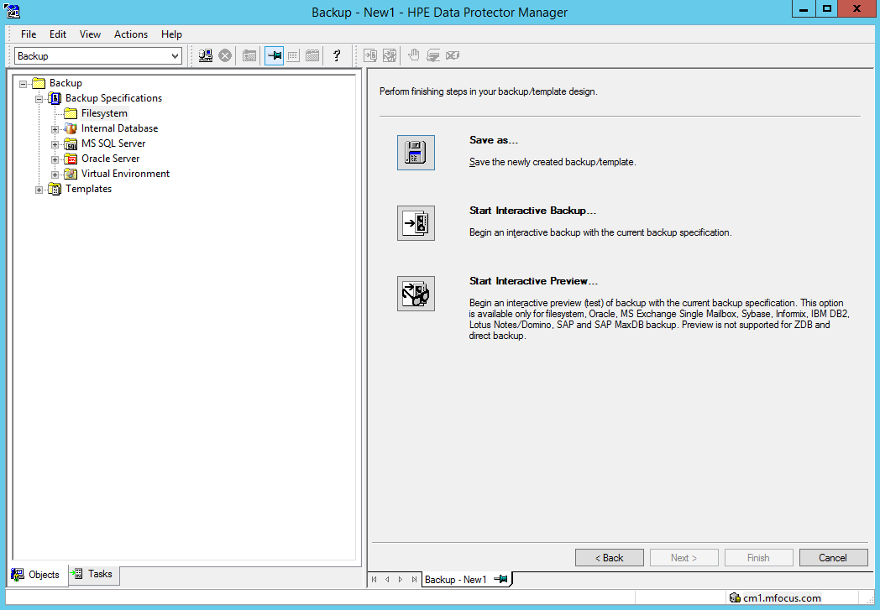

### File Backup with Source side Deduplication

This process is identical to the process for the previous backup except that you select Source Side Deduplication on the Create New Backup Screen:

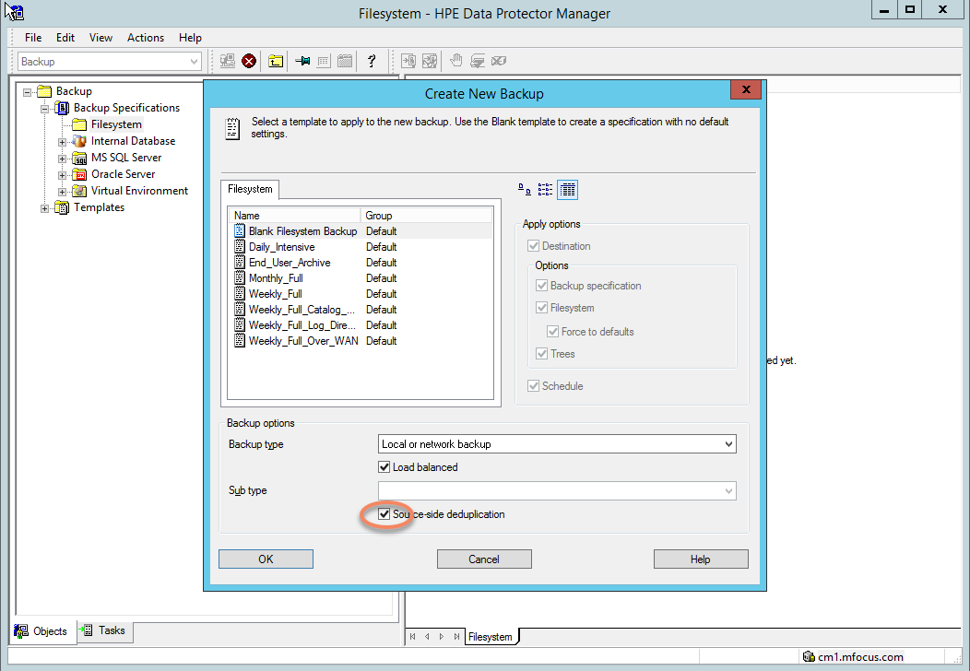

On the next screen you’ll see that some servers are greyed out and can’t be selected. That’s because only servers with media agents installed can do source side deduplication

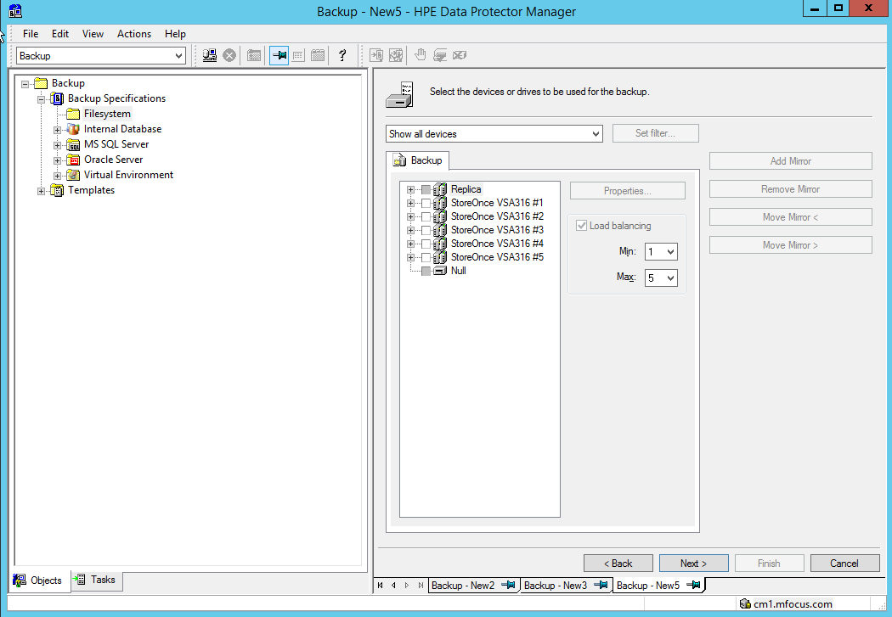

And under devices some targets will be greyed out since source side deduplication has to have a catalyst target. Only the StoreOnce library meets that requirement here.

Other than that everything else is the same.

### File Restore

In the restore Context, expand the Filesystem selection.

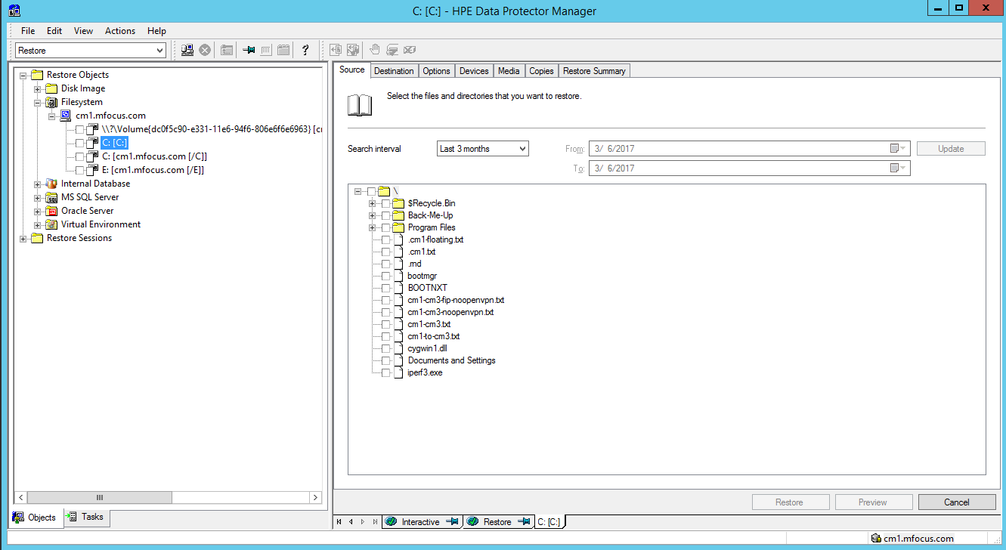

Click on C: [C:]

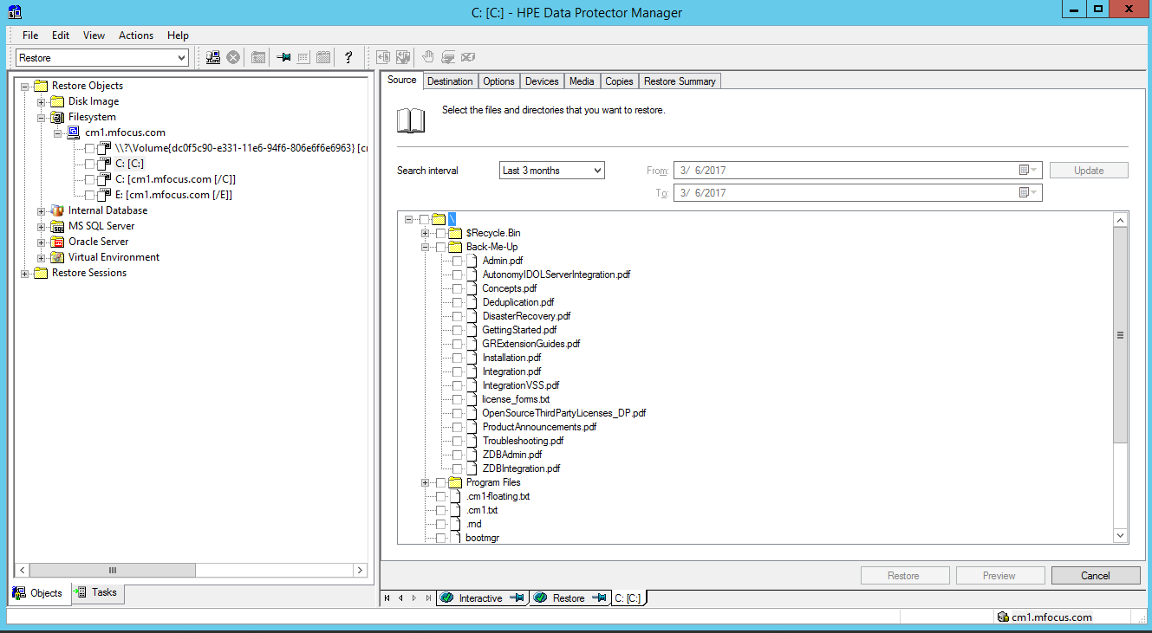

Expand the Back-me-up directory – this shows restoring files. Right click on one of the files and you can show that we can restore file versions.

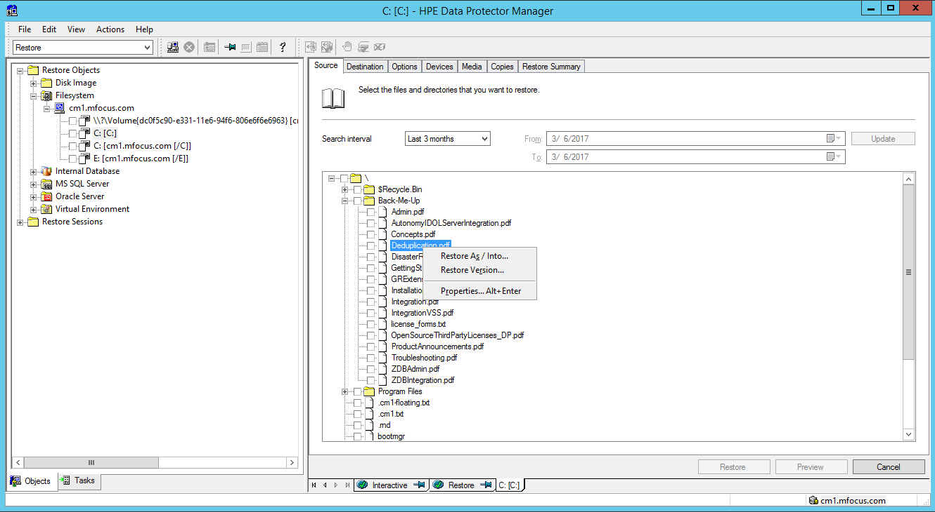

By clicking on the Destination tab you can show how we can restore to a different server, a different location, and how we handle conflicts.

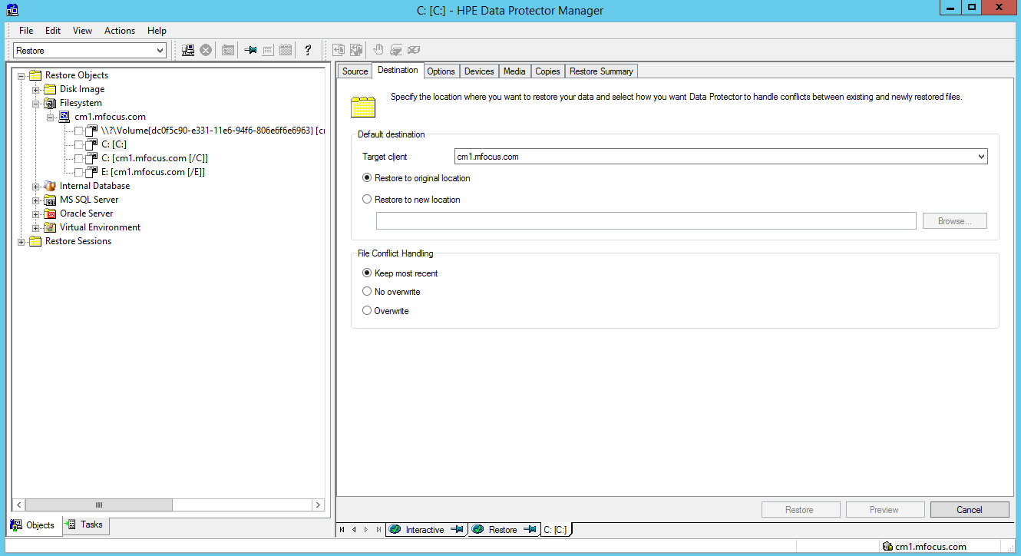

Under Options we can show that we provide whatever the customer needs in terms of restore flexibility. This screen also illustrates the IDOL integration.

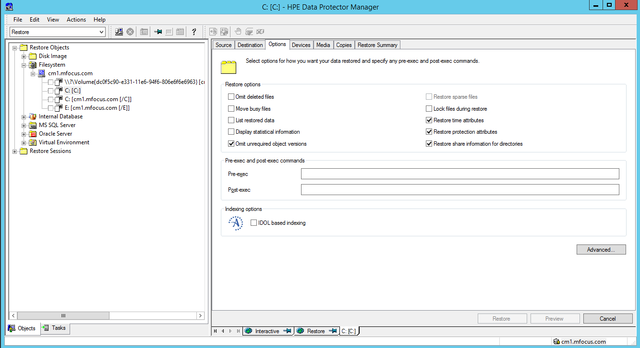

The only other item of real interest here is the copies tab – which allows us to select which copy of a backup (assuming we have multiple copies) we want to restore from.

Go ahead and perform a restore if you’d like, but put it in the TEMP directory so you can show that it was indeed restored.

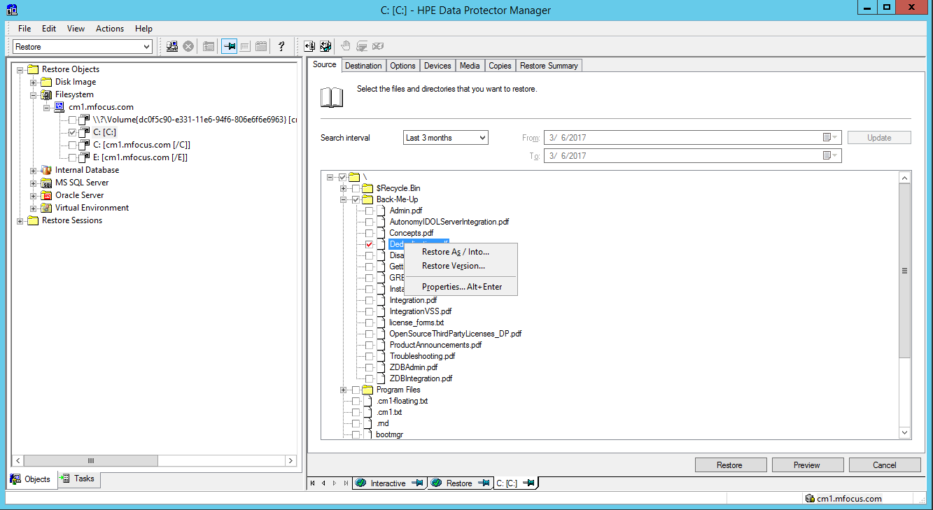

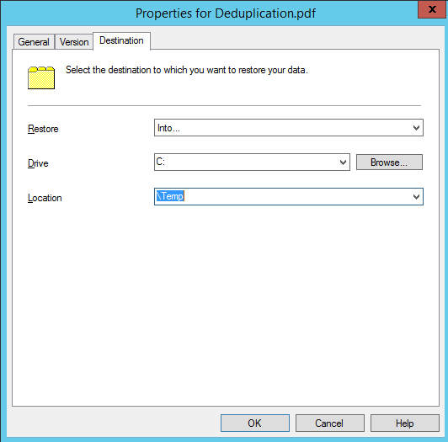

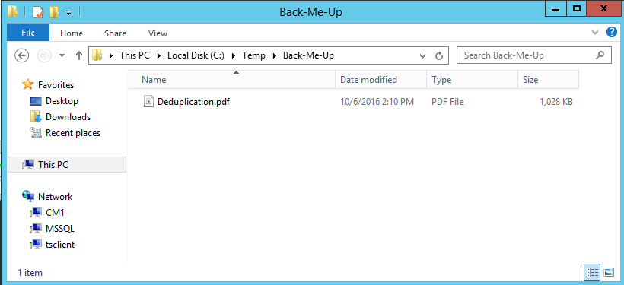

Here is the file.

## 5.1 SQL Backup and Restore

### SQL Backup

In the backup Context click on MS SQL Server and you can see there is already a backup there called “New 2.”

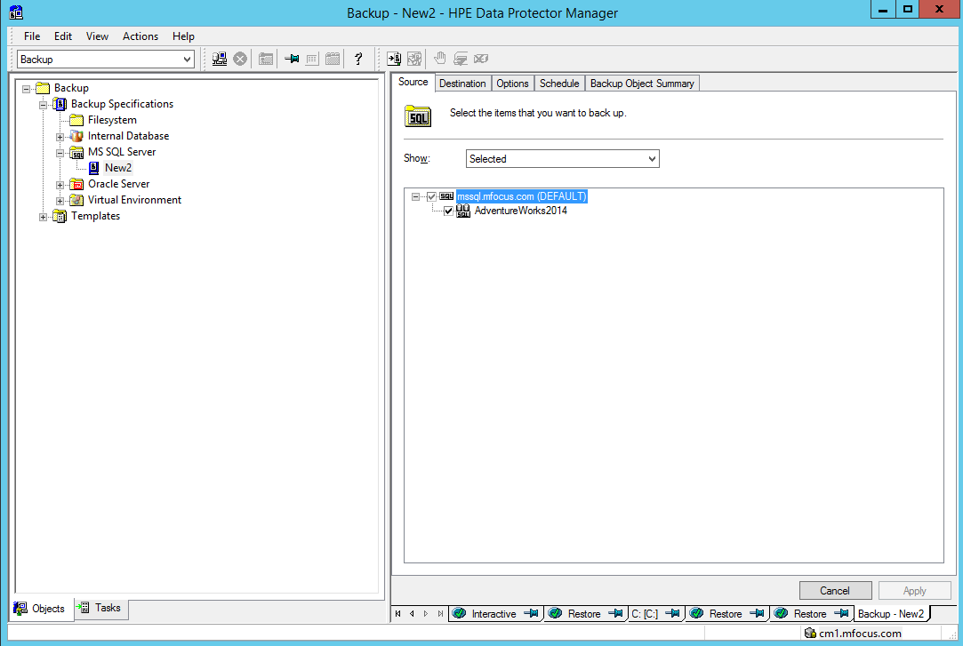

Let’s go to the Destination Tab:

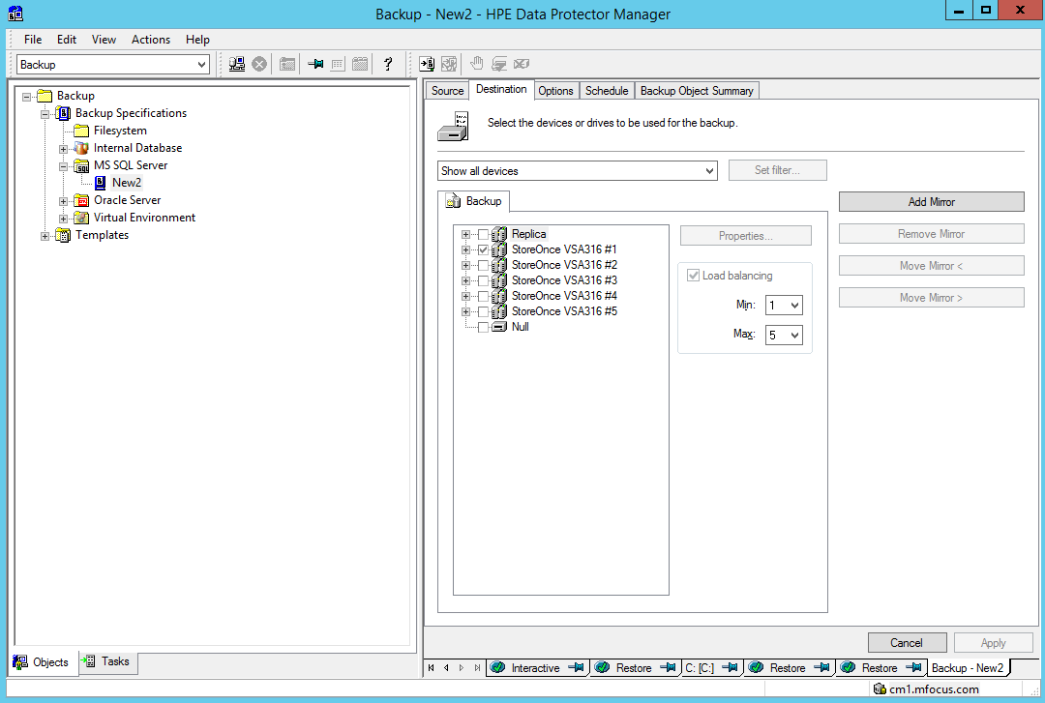

Choose your assigned VSA, and choose as your gateway the SQL Server. Due to some network limitations in the BLUESHIFT Demo environment, this will give you the best performance.

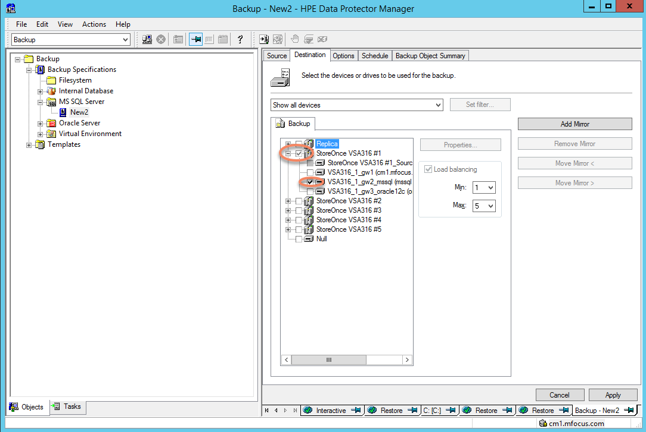

And then move to the options screen. Here we can set application specific items.

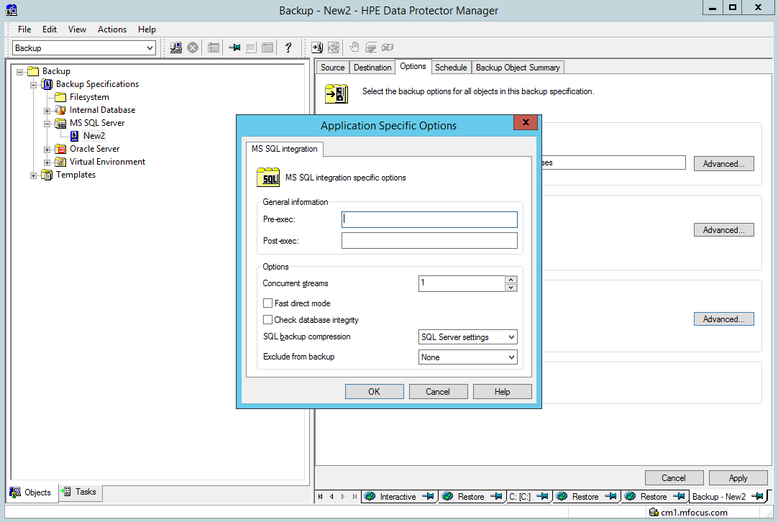

Go ahead and start the backup. After this everything proceeds as with all backup specifications.

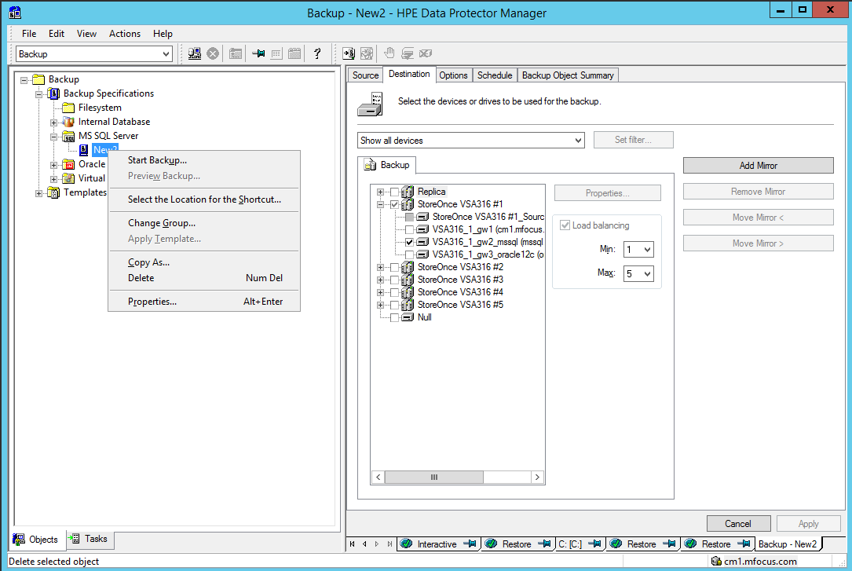

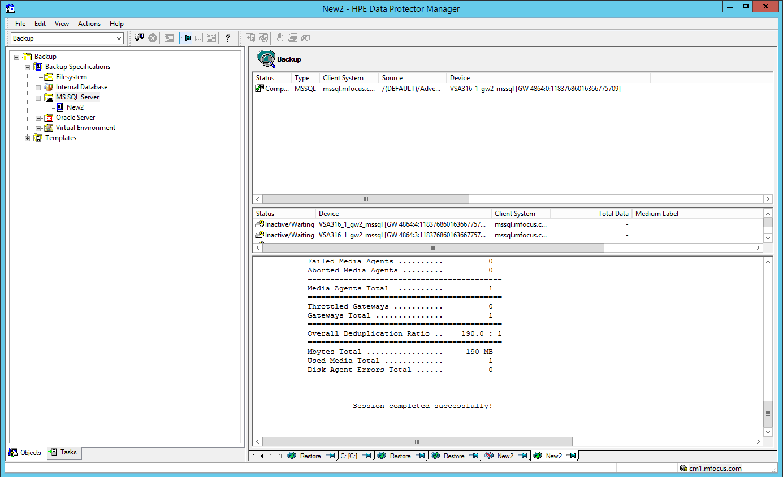

Note: Sometimes the backup will fail for no apparent reason. Normally all it takes is to logon to the SQL Server (the login is in your invitation email) and reboot it.

## 

### Restoring a SQL database

In the Restore Context select the SQL FULL backup

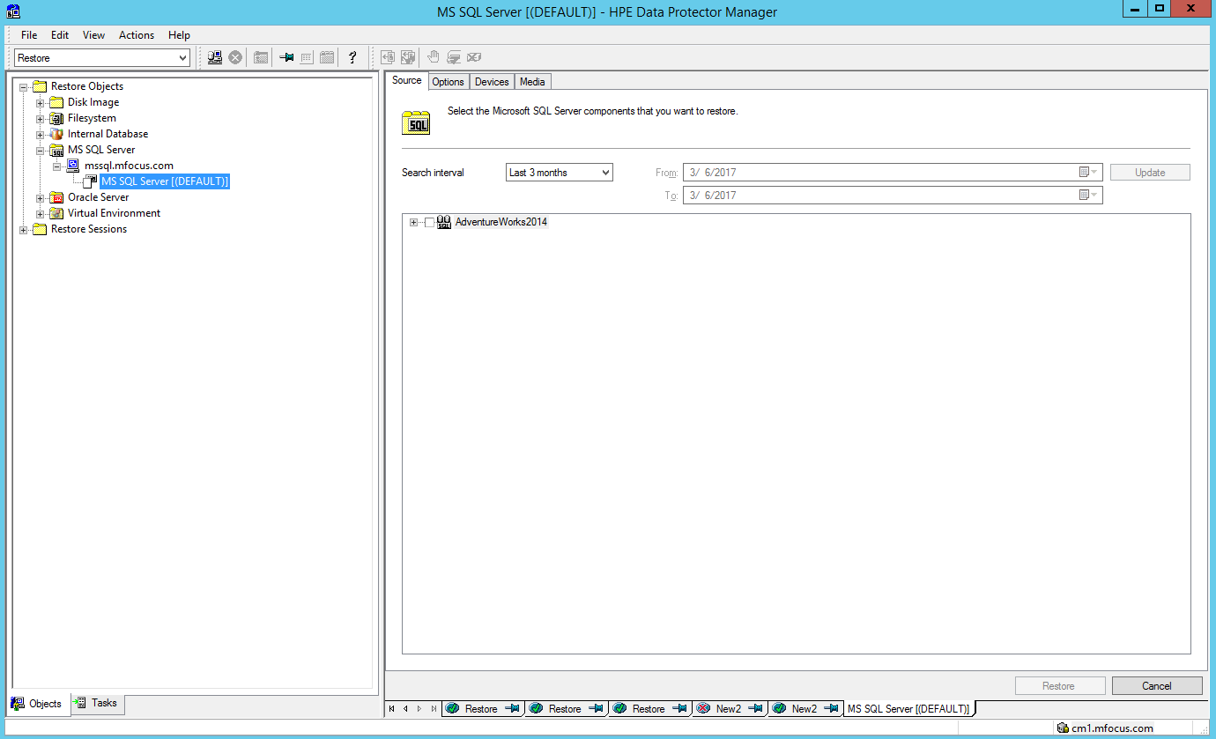

Right click on the Adventure works database and, select properties and a Properties screen will appear. Then select the point in time to restore from. 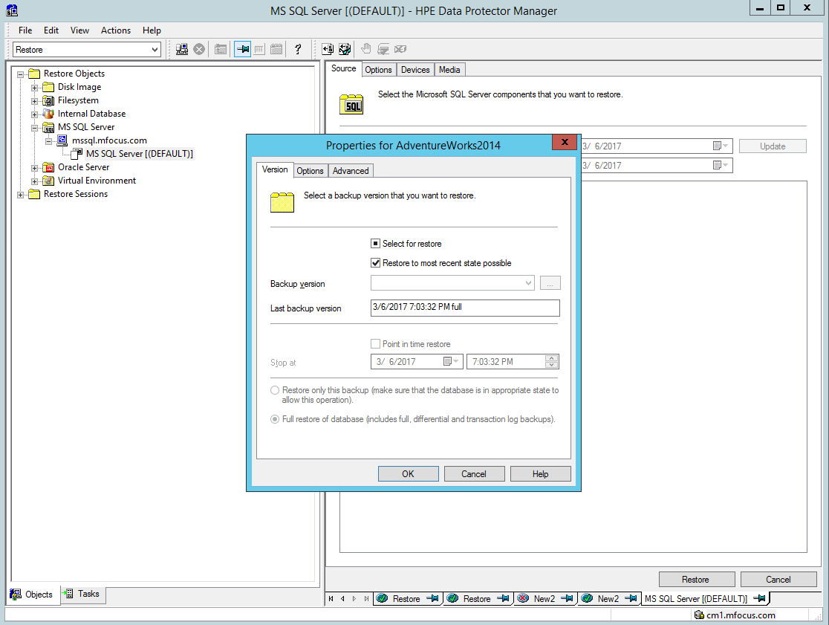

Selecting the Options tab allows us to specify the state we want the database in when we’re done restoring.

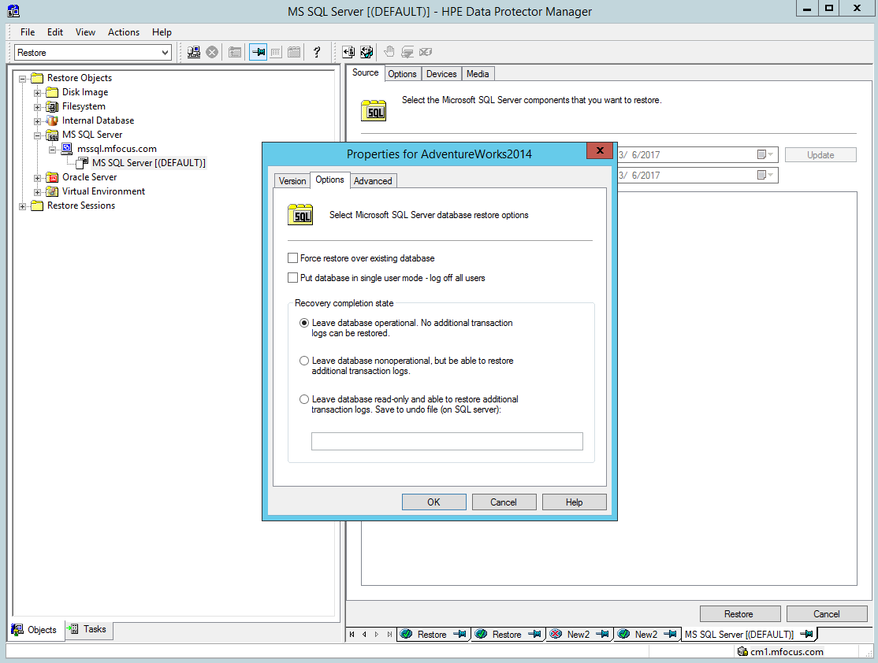The Advanced tab allows the restore to be done to a different database name

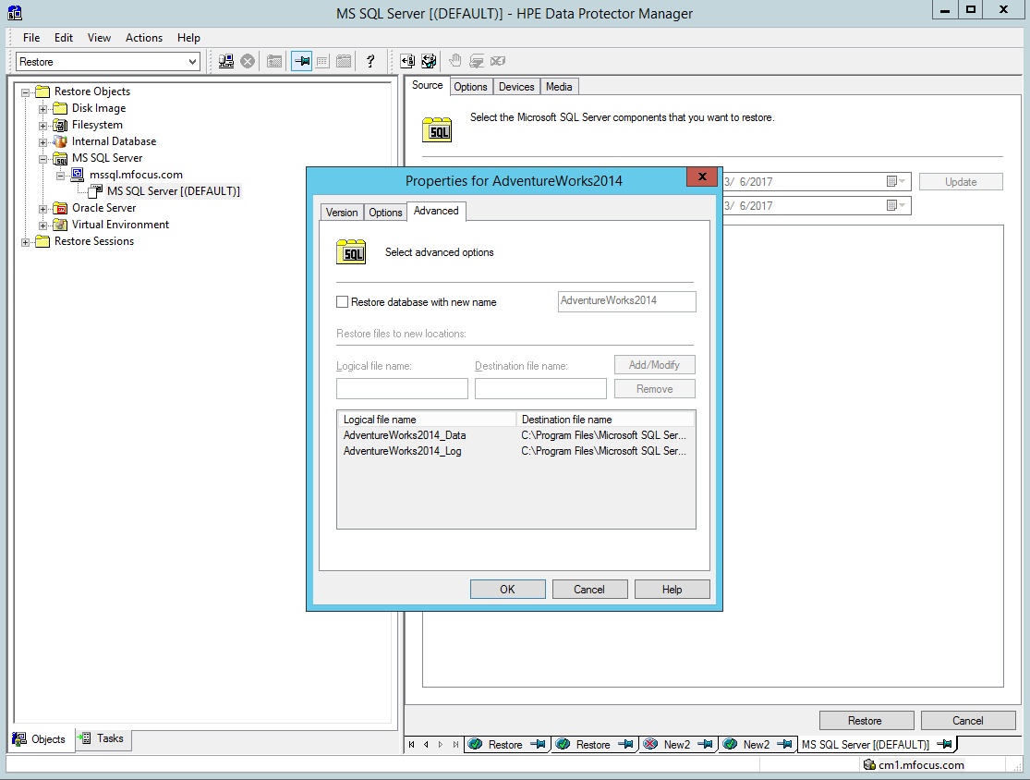

Having set these parameters we can also set restore location options in the main options window

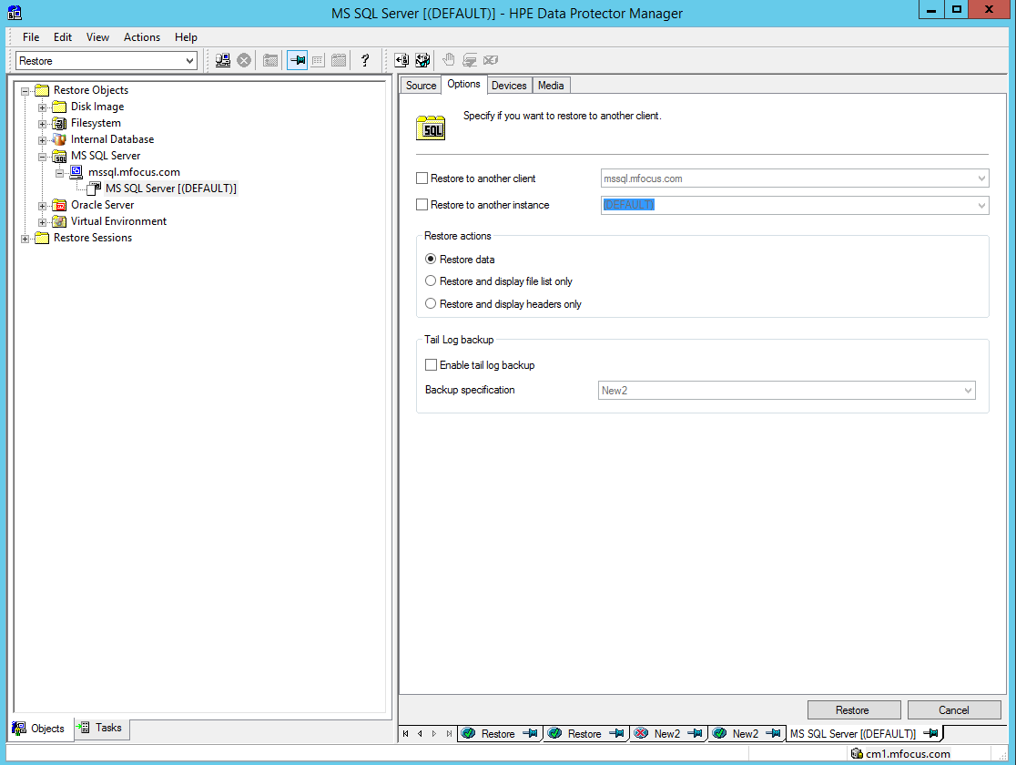

## 5.2 Oracle Backup

### Oracle Backup

In the backup Context click on Oracle Server. For simplicity the backup has already been defined. 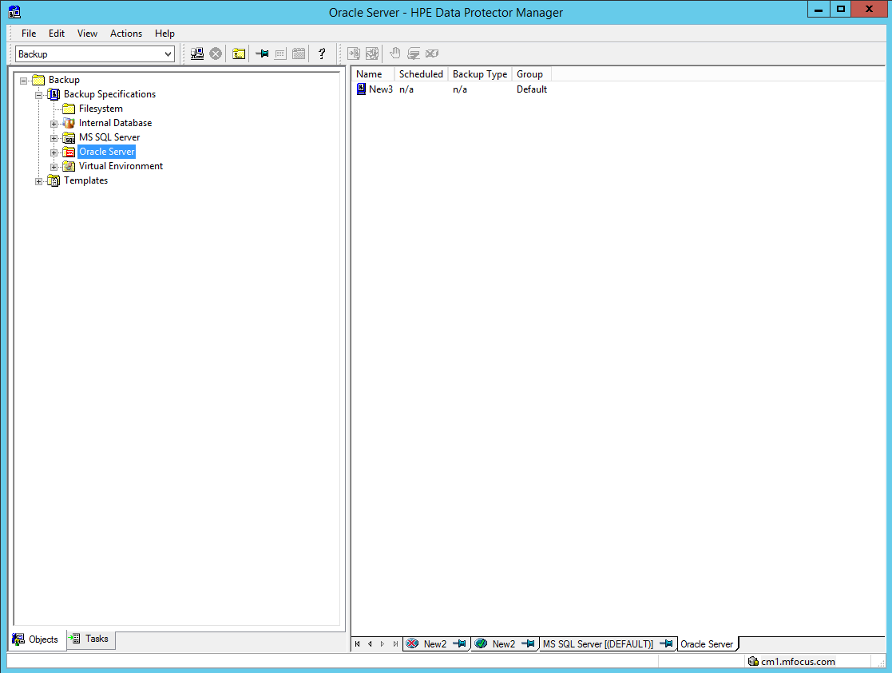

Expand out the New 3 Backup specification and you will see this:

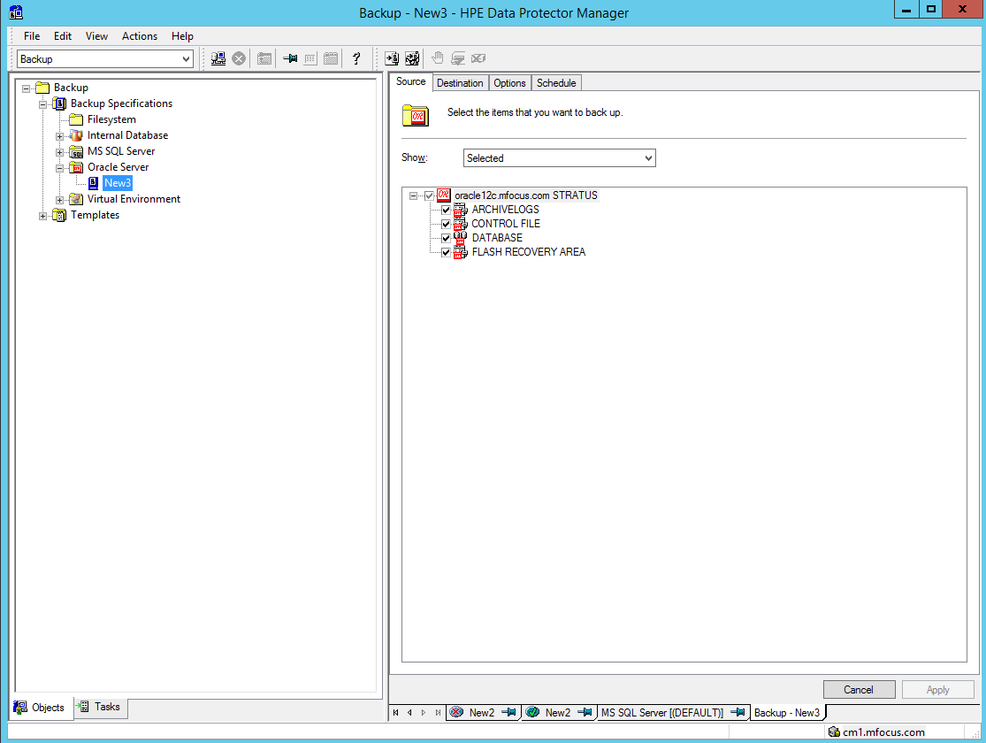

Choose your assigned VSA, and choose as your gateway the SQL Server. Due to some network limitations in the BLUESHIFT Demo environment, this will give you the best performance.

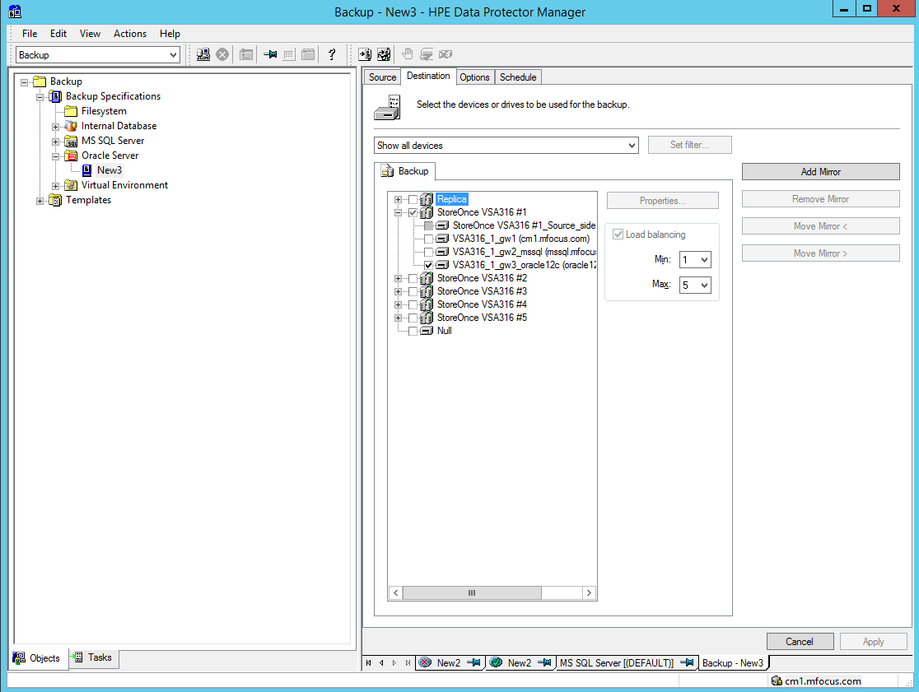

On the next screen click on the advanced button under “set integration specific options” and show that DP actually creates an RMAN script to perform the backup. Point out that this script can be modified if desired to adjust to the user’s backup requirements. Editing of the script is available after the backup specification has been saved. Also point out that Oracle backups can also be done from within RMAN on the Oracle server (not currently implemented in our demo)

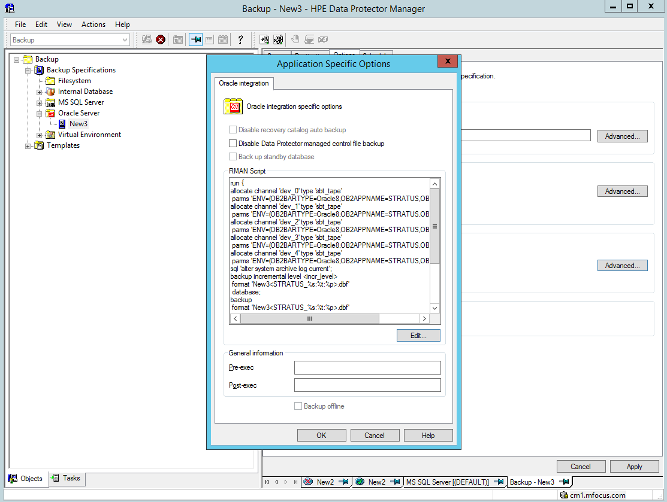

Go ahead and execute the New3 Backup

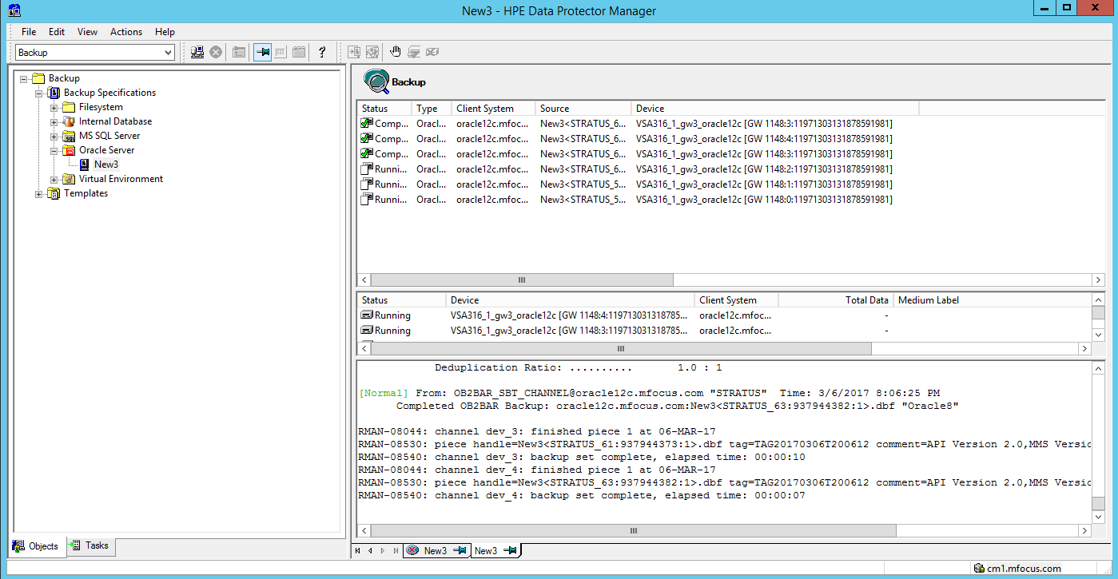

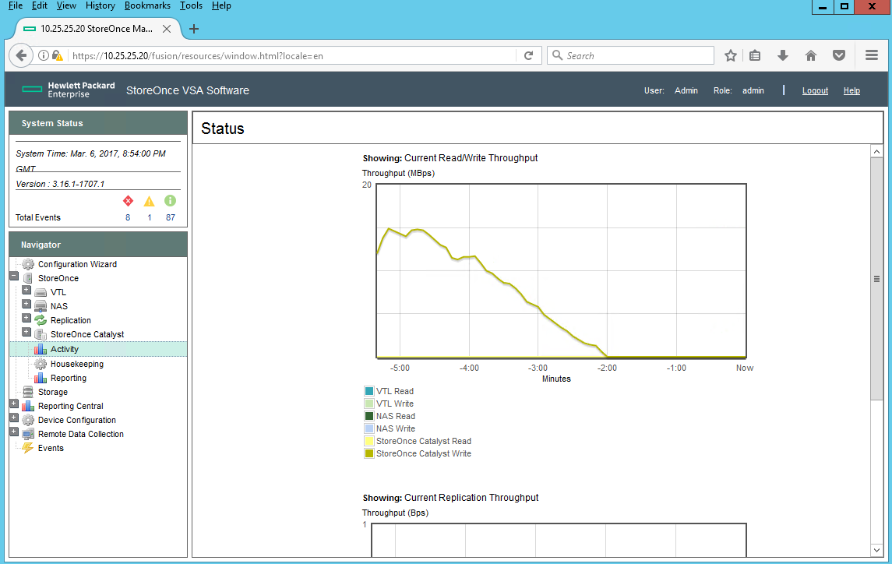

### 

### Oracle Restore

In the Restore context, expand the Oracle Server to show the existing backup, and expand that to show the individual databases.

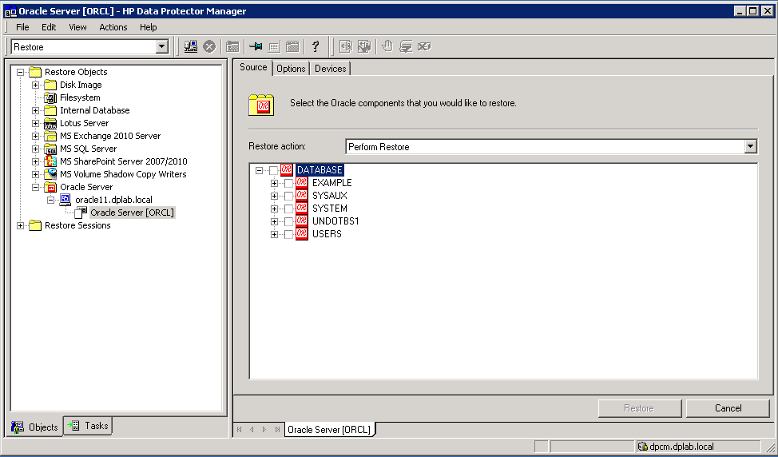

Here we can show that there are several different ways to restore

Just restore the database

Restore and recover

Just recover using the transaction logs

Create a duplicate database

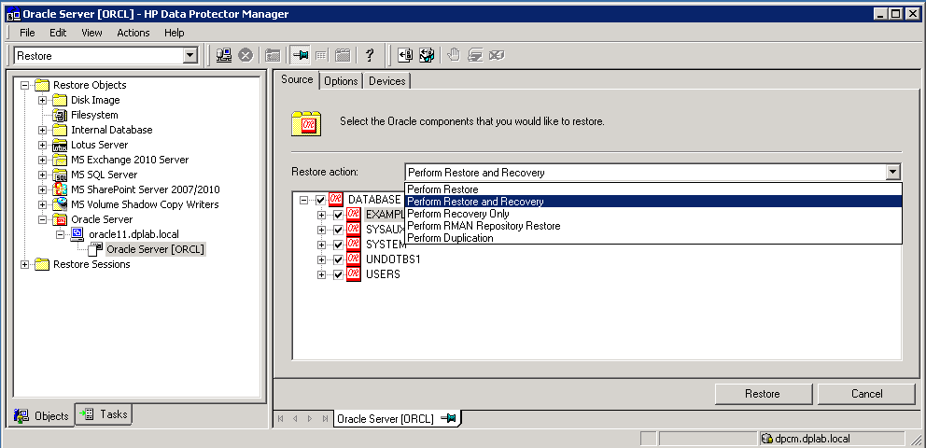

Select Restore and Recover, then click on the Options tab.

There are a number of options available here – most important to point out are the granularity of the restore point…

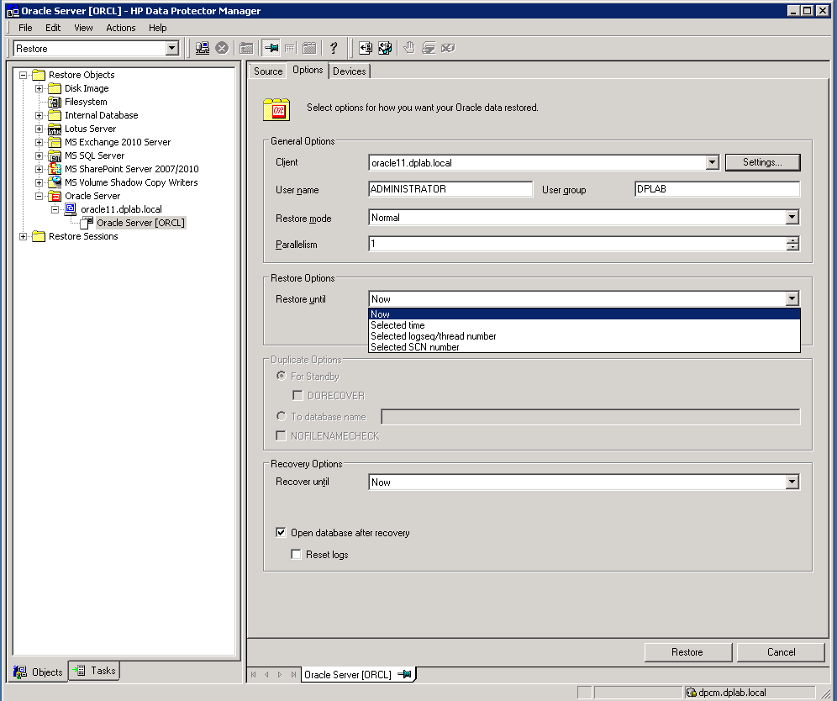

….And the recovery point. At this point don’t do the actual restore – you really need to shut down the database for that – too much work.

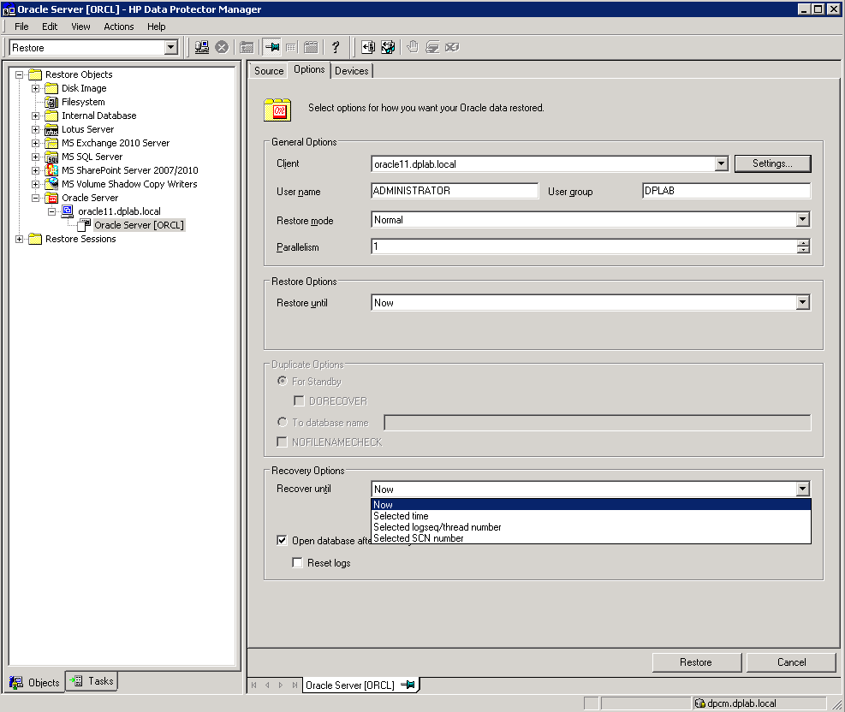

## 5.3 Exchange Backup

### Exchange Backup

The BLUESHIFT offering will have one standalone Microsoft Exchange 2013 Server. So Data Protector will be able to back up the database from only one Microsoft Exchange Server system. Data Protector sends backup and restore requests directly to the Microsoft Exchange Server system.

When you back up a Microsoft Exchange Server database, the following files are automatically backed up: l database files (.edb) l transaction logs (.log) l checkpoint files (.chk) However, depending on the Microsoft Exchange Server backup type you select, not all files are always backed up.

Create a backup specification using the Data Protector GUI (Data Protector Manager).

1. In the Context List, click Backup.
2. In the Scoping Pane, expand Backup Specifications, right-click MS Exchange 2010+ Server, and click Add Backup.
3. In the Create New Backup dialog box, specify Backup type (VSS backup type). For details, press F1. Click OK.
4. In Application system, select the Microsoft Exchange Server system that you want to back up Click Next.
5. In the Configure MS Exchange 2010+ Server dialog box, provide the domain, username, and password to browse or backup or recover the Exchange server.

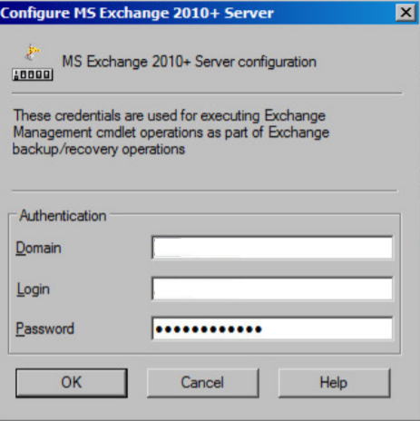

1. The MS Exchange 2010+ Server is configured. Exit the GUI

### Exchange Restore

1. In the Context List, click Restore
2. In the Scoping Pane, expand MS Exchange 2013 Server
3. In the Source page, Data Protector displays all Microsoft Exchange Server databases backed up from the Exchange server
4. Select the Microsoft Exchange Server databases to restore.
5. When you select a database, the Properties for Database dialog box is displayed automatically. Specify a restore method and click OK. For databases that are part of a DAG, the default restore method is Repair all passive copies with failed status. For standalone databases, the default is Restore to the latest state.

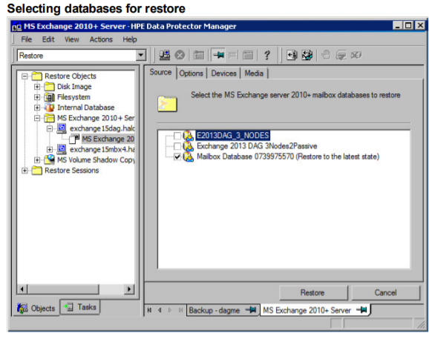

1. In the Devices page, select the devices to use for restore.

For details on how to select devices to be used for restore, see the HPE Data Protector Help index: “restore, selecting devices for”

1. Click Restore
2. In the Start Restore Session dialog box, click Next
3. Specify Report level and Network load.

NOTE: Select Display statistical information to view the restore profile messages in the session output.

1. Click Finish to start the restore.

The statistics of the restore session, along with the message Session completed successfully is displayed at the end of the session output.

## 5.4 VMware and VMware GRE

1. **VEPA-based Snapshot backup**

This functionality is brand new with this release. We can show 1) VEPA-based snapshot backups, and 2) the Granular Recovery Extension (GRE)

**PLEASE NOTE:** The VM clients do not come up with your environment automatically at this release. Please go into the vCenter console and start the VM that you are planning on backing up in the Demo. Please see the GRE section below for the instructions on logging in. Once logged in, start the VM you want to back up with Data Protector. If you don’t start the VM first, the backup will fail. This is due to the way this demo environment is instantiated. It is not a bug in Data Protector.

We start with the CLIENT, which has been imported into Data Protector:

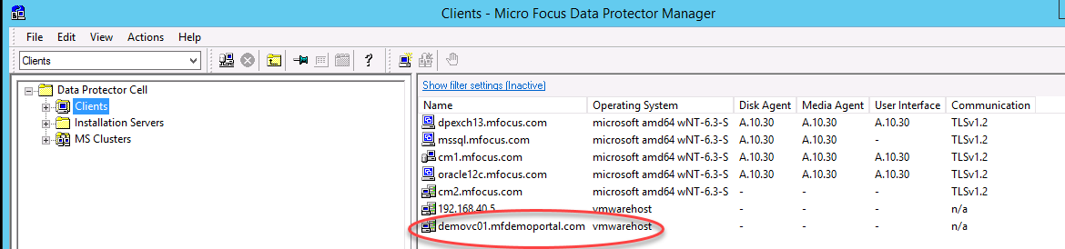

No action required here, other than to note that vCenter client MUST be here in order for DP to communicate with it.

Next, we configure a backup:

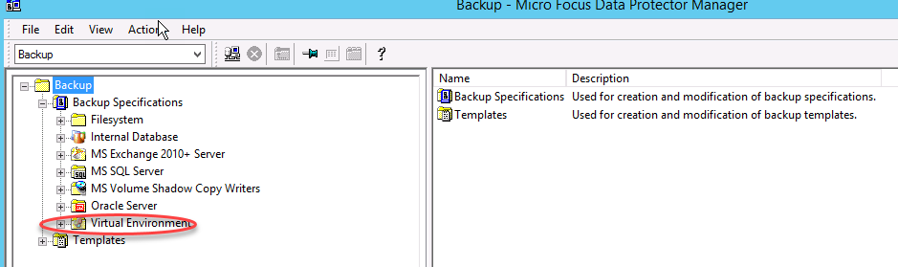

Right click on Virtual Environment and Add Backup:

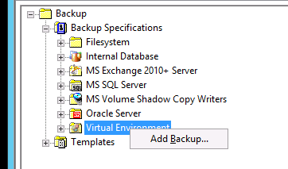

Next take the default:

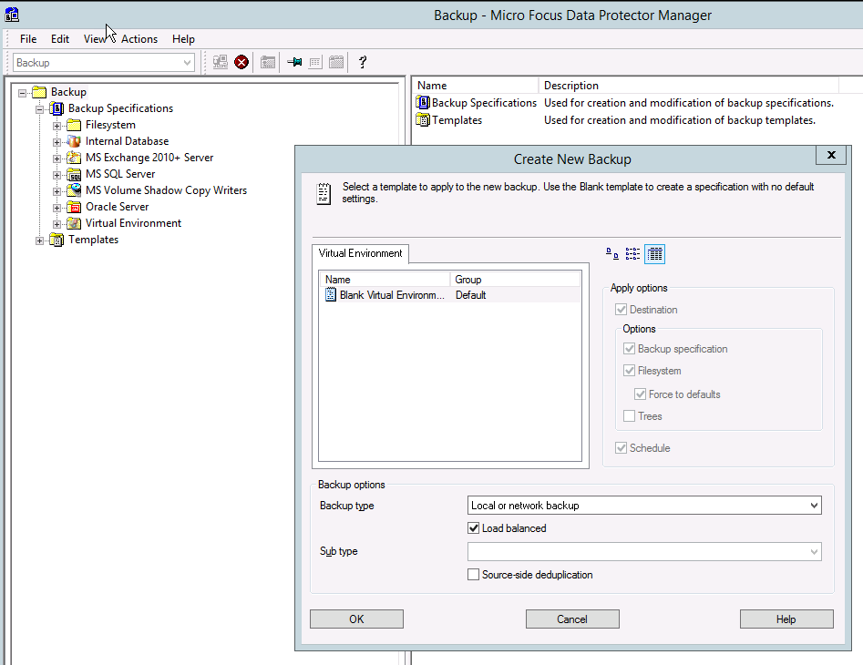

Pick Next

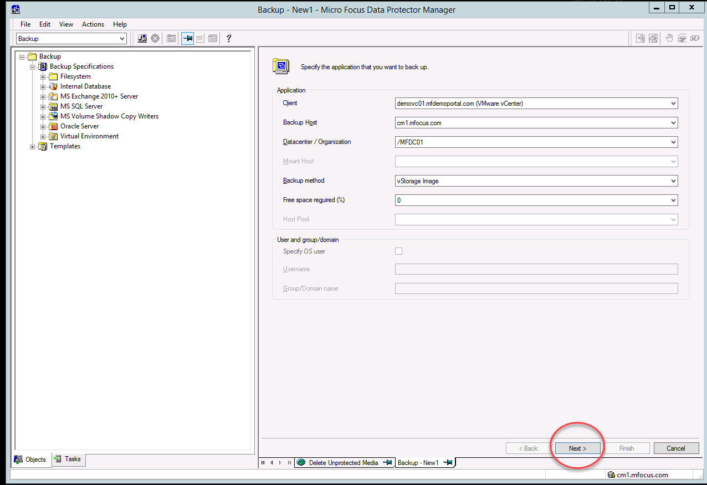

Then pick the virtual disk you want to back up. There are 3 Windows VMs in this Demo environment.

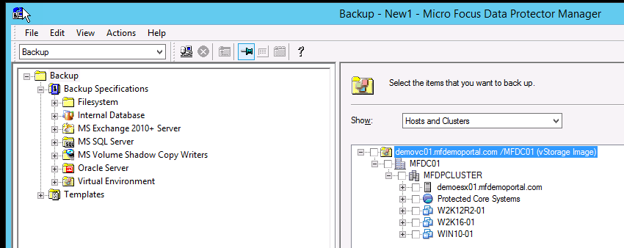

We recommend the Win10-01 because the disk is pretty small and it won’t take a long time to backup.

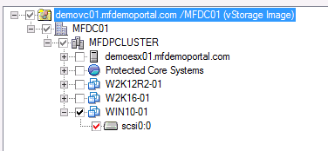

Now choose the StoreOnce you want to back up to:  
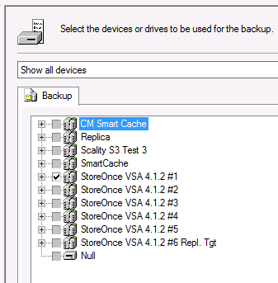

Save the backup and start it

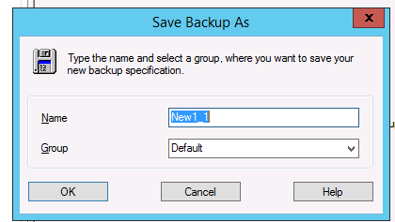  
Make sure you set retention to no more than one day, as in the other facets of this demo environment.

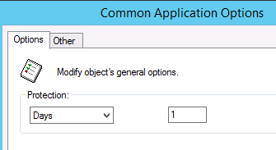

The backup should proceed normally. If you login to your StoreOnce VSA, you can see the data transfer as it happens:

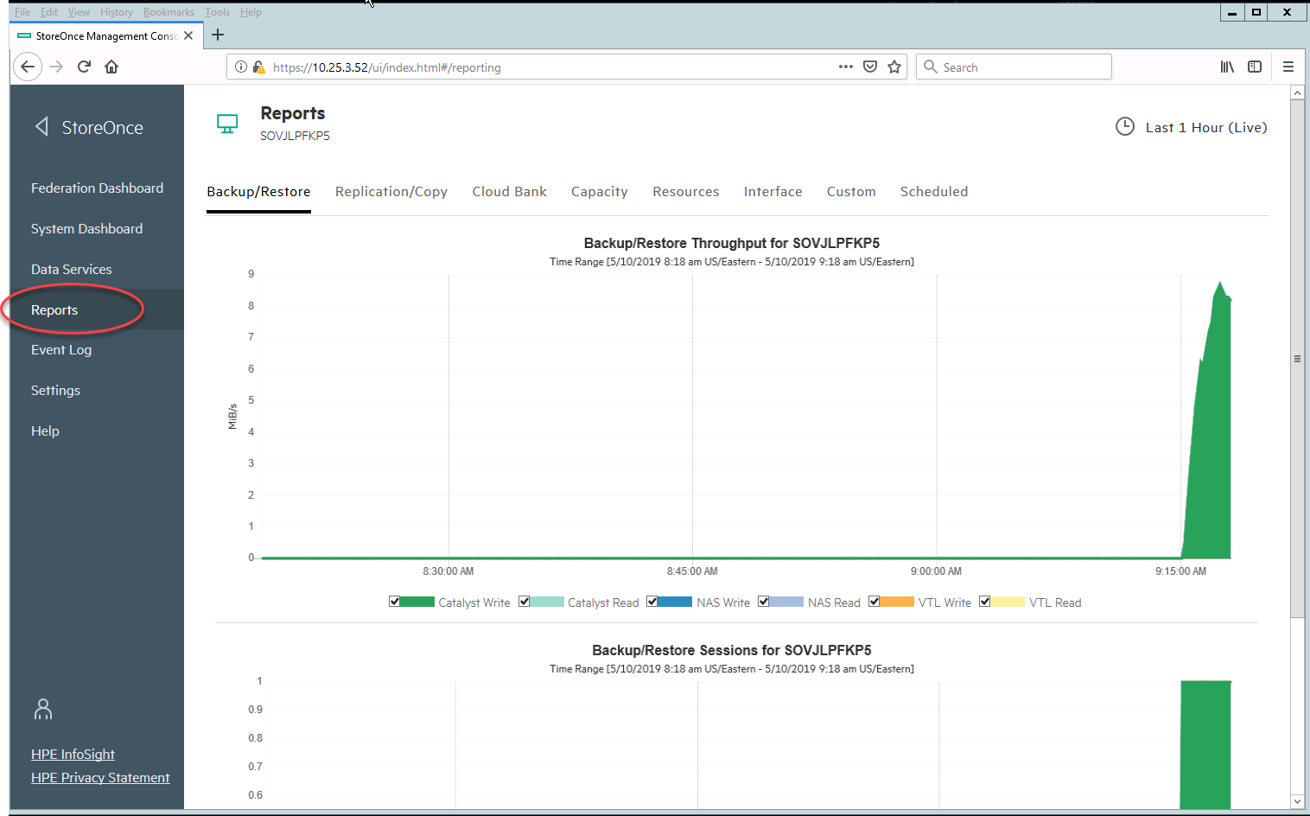

1. **GRE- Granular Recovery Extension**

Now we move on to the GRE functionality, which is accessed through the vCenter Server. Go into a browser on CM1 and type:

<https://demovc01.mfdemoportal.com>

Please choose Launch vSphere Web Client (FLEX) as DP does not yet support the HTML5 option

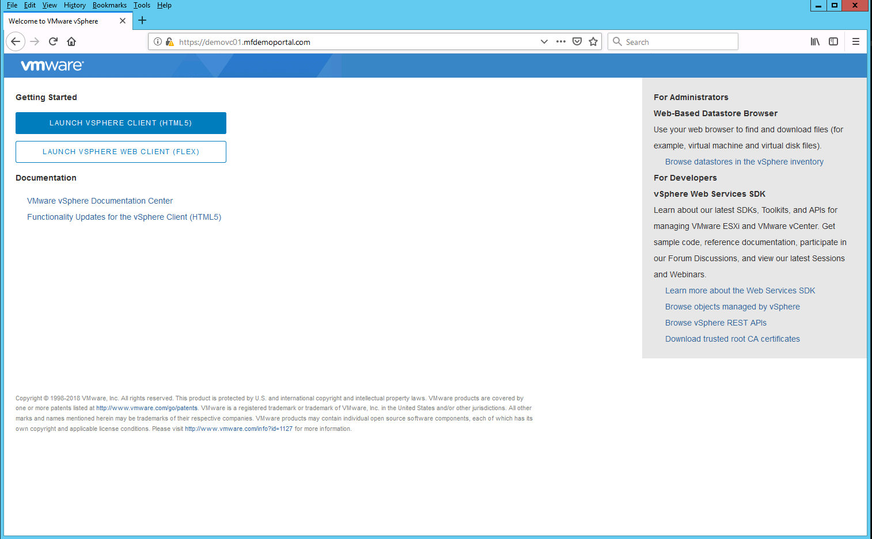

The login is [administrator@demonet.local](mailto:administrator@demonet.local)

Password is go.MF.admin123!

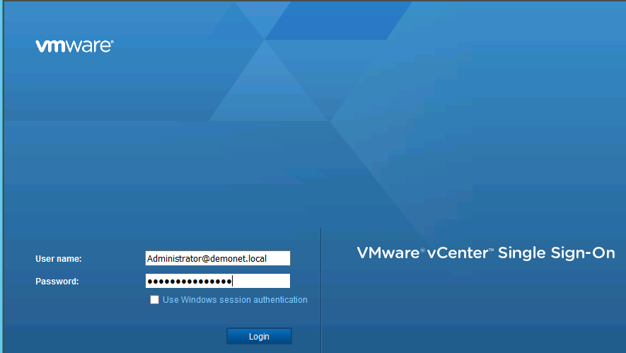

Since this version uses Abobe Flash, you may have to try twice to get the GUI to come up. If it asks to allow Flash, please say YES.

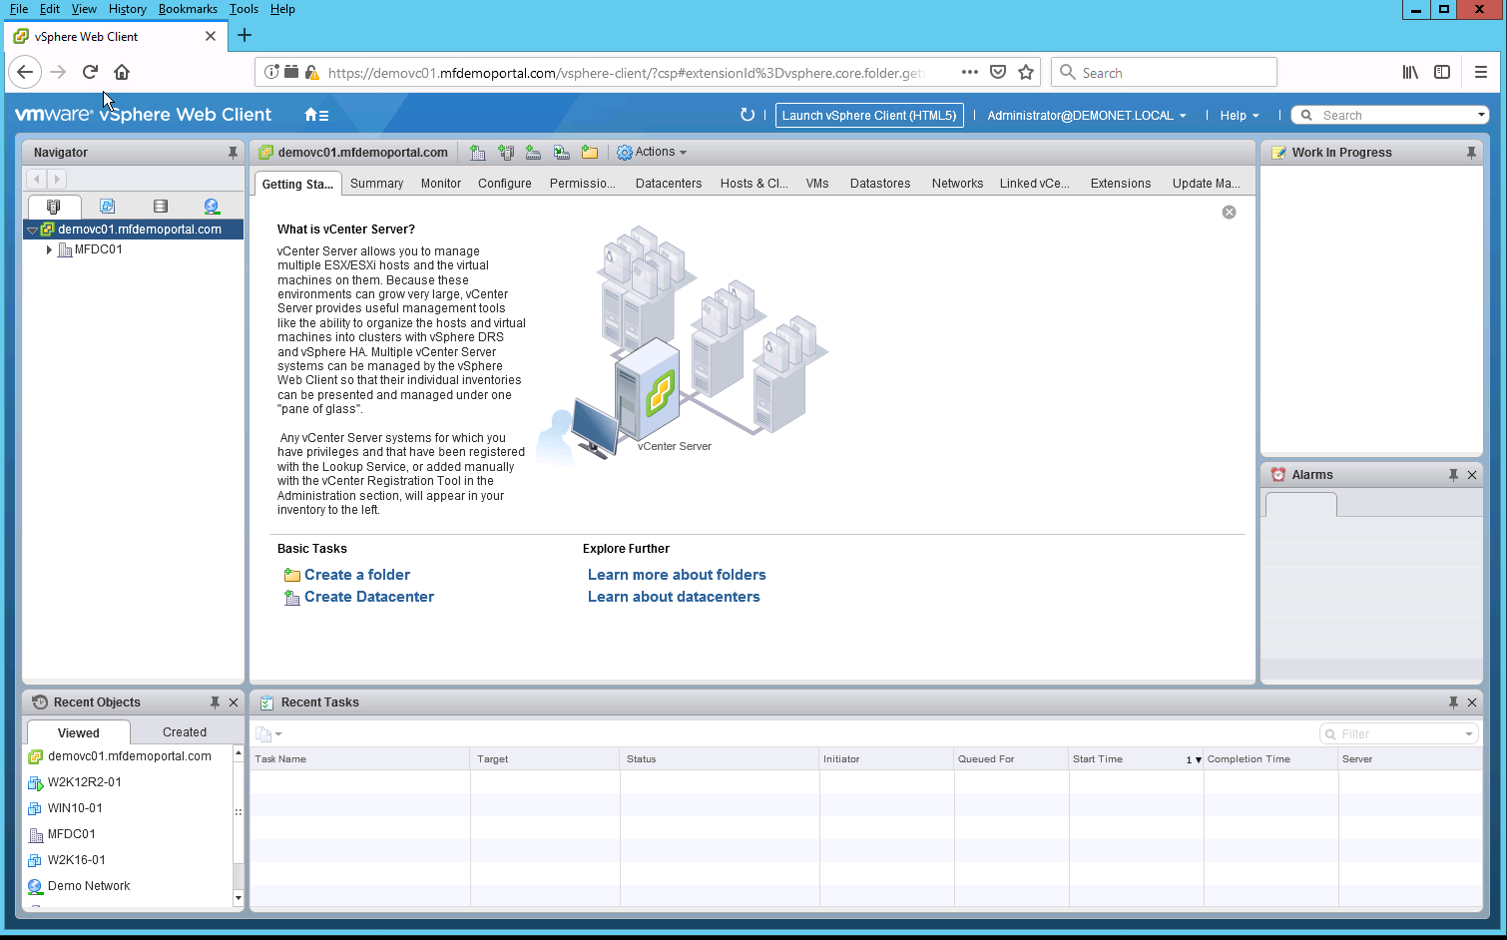

Now select one of the three Windows VMs (you will see Granular Recovery as one of the options under Configure:

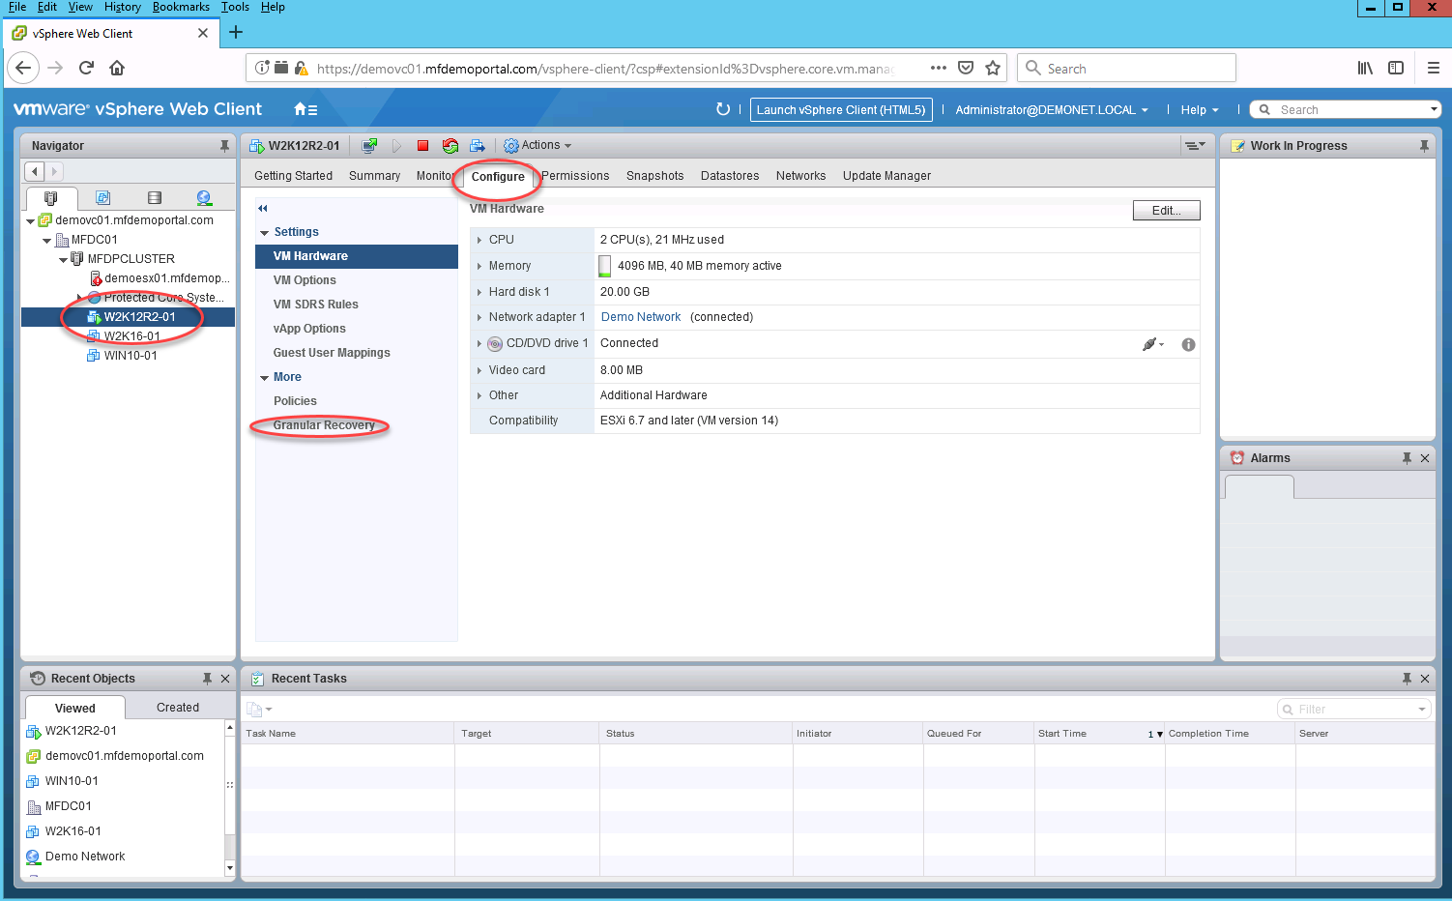

Now click on Granular Recovery:

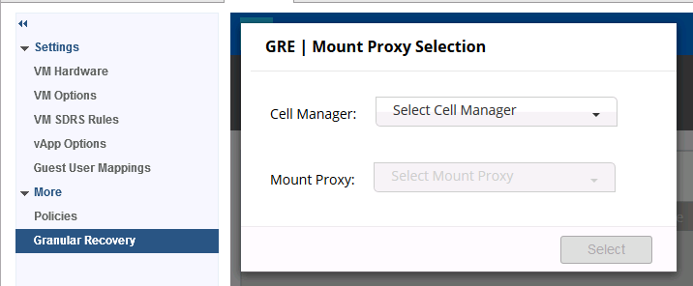



Select the Cell Manager and now you will see this:

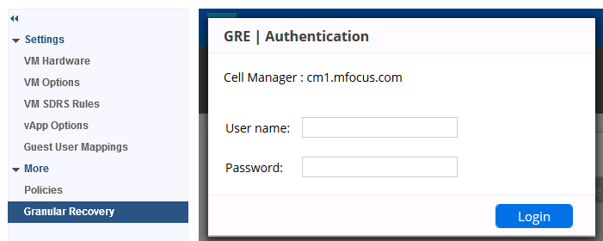

The User name is **Administrator|mfocus|\***

The Password is **Dpadmin123\***

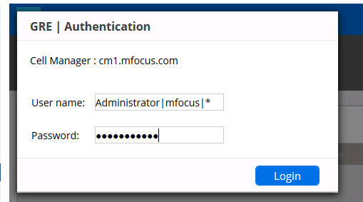

You should now see this:

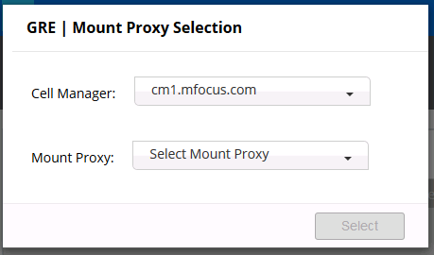

Choose the only option listed

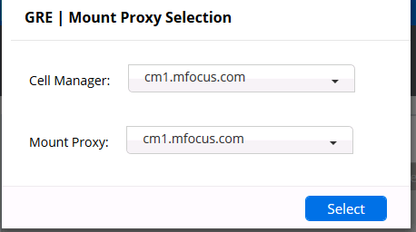

Then you will see something like this:

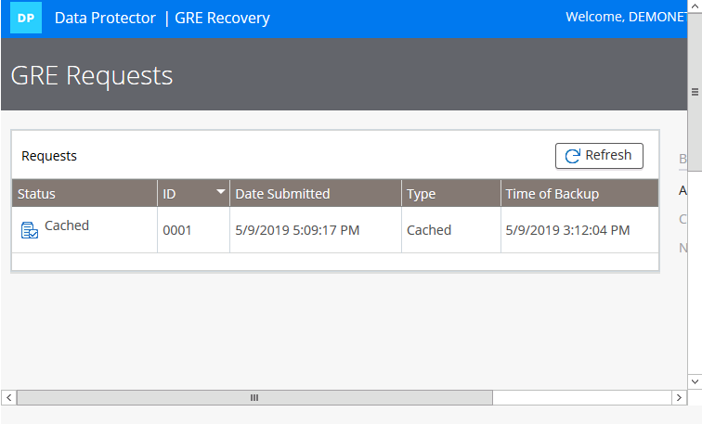

Scroll over to the right and pick **New Request**

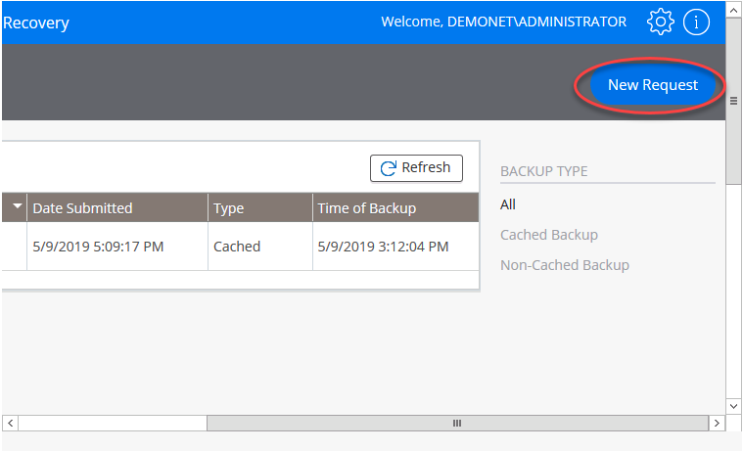

Depending on which backup you did, there may be one or more backup jobs shown here:

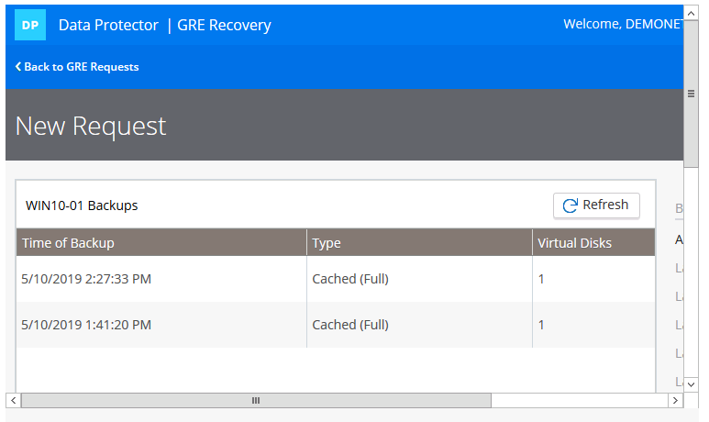

Now pick the one you want:

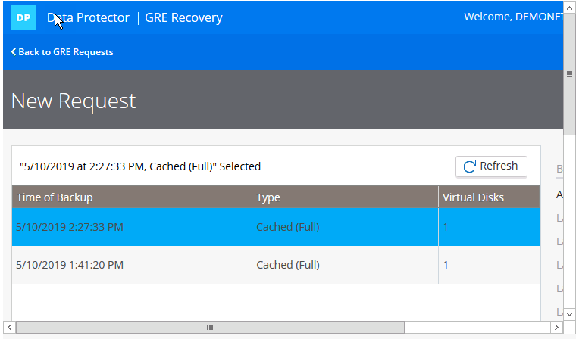

Then scroll down and pick the disk you are interested in:

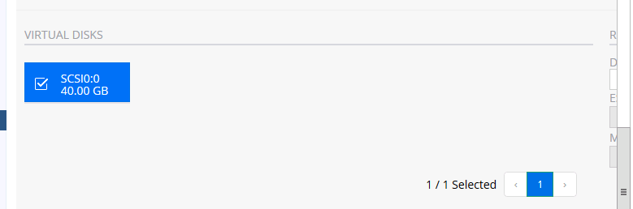

Then Send Request

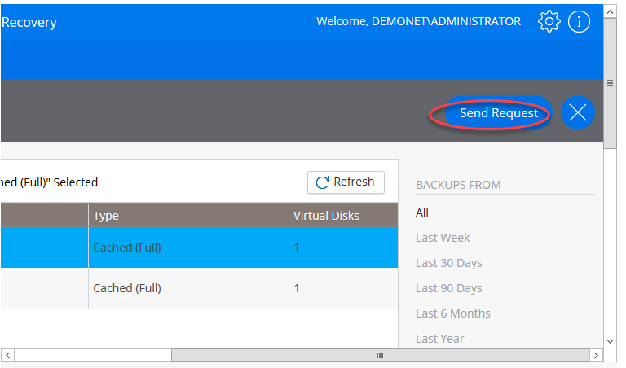

Now you can browse the files in the backup:

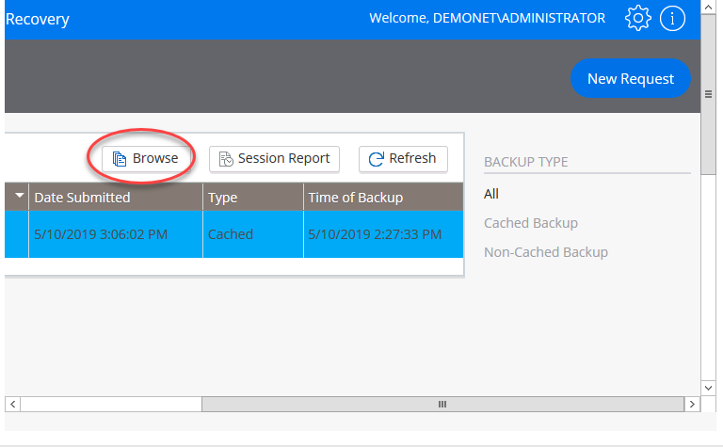

This will then give you what is in the backup (it takes a little while):

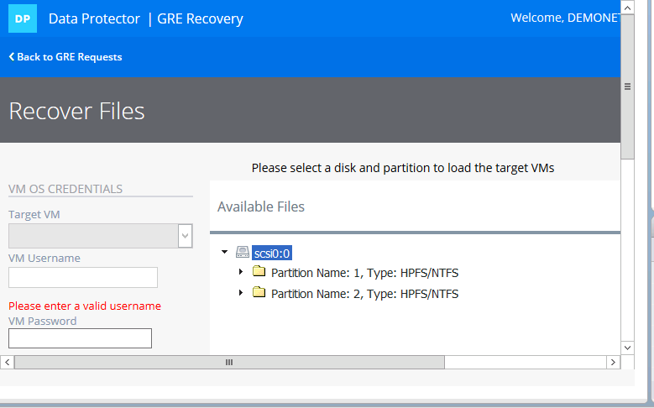

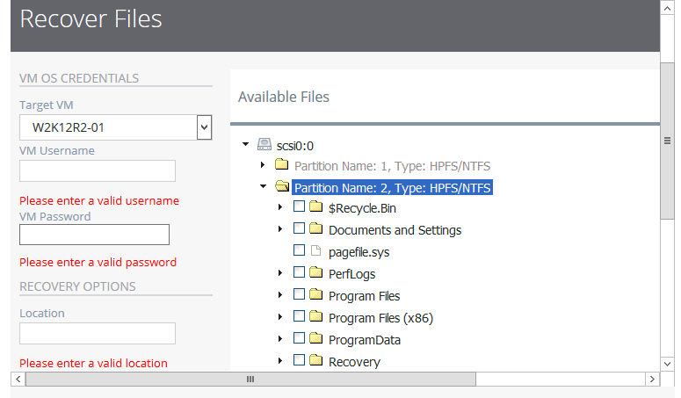

At this point, we’re done. We don’t usually demo the actual restore of files.

# Section 6. DP 10.10 (and above) Native Reporting

Data Protector 10.10 added some new Native Reporting Features. On the Home context, you will see this if you click on **Reports**:

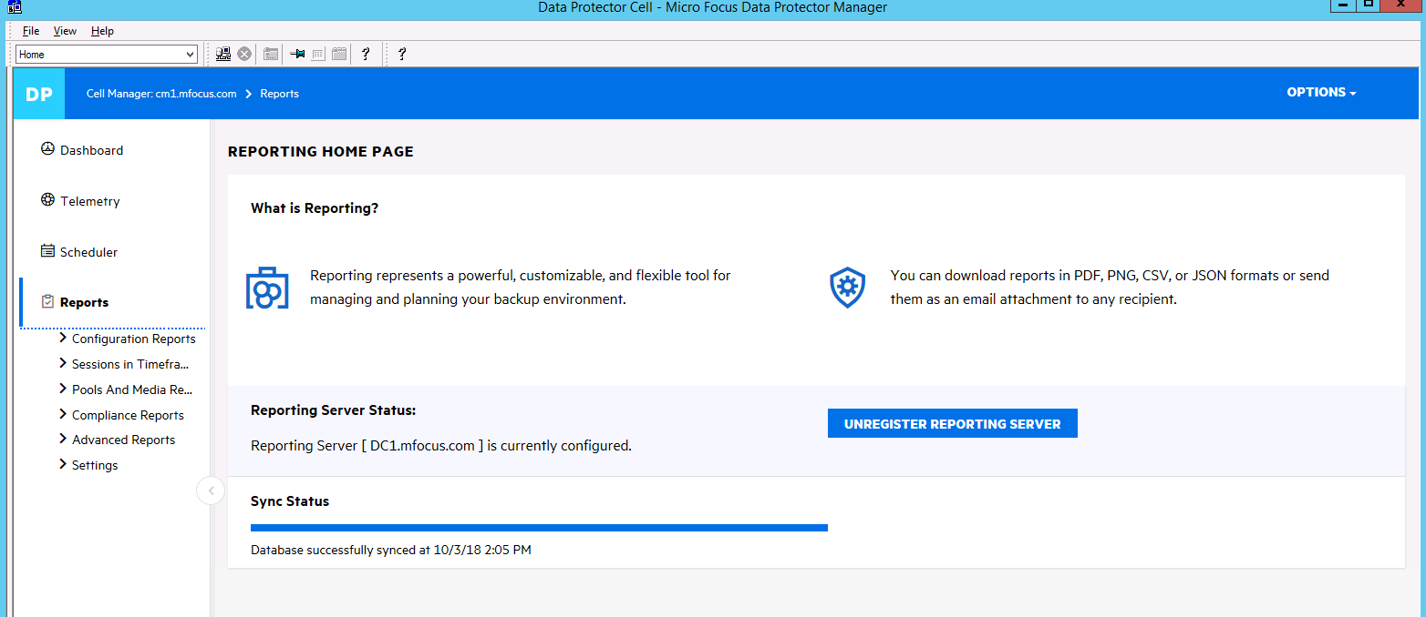

Here is a list of reports per category:

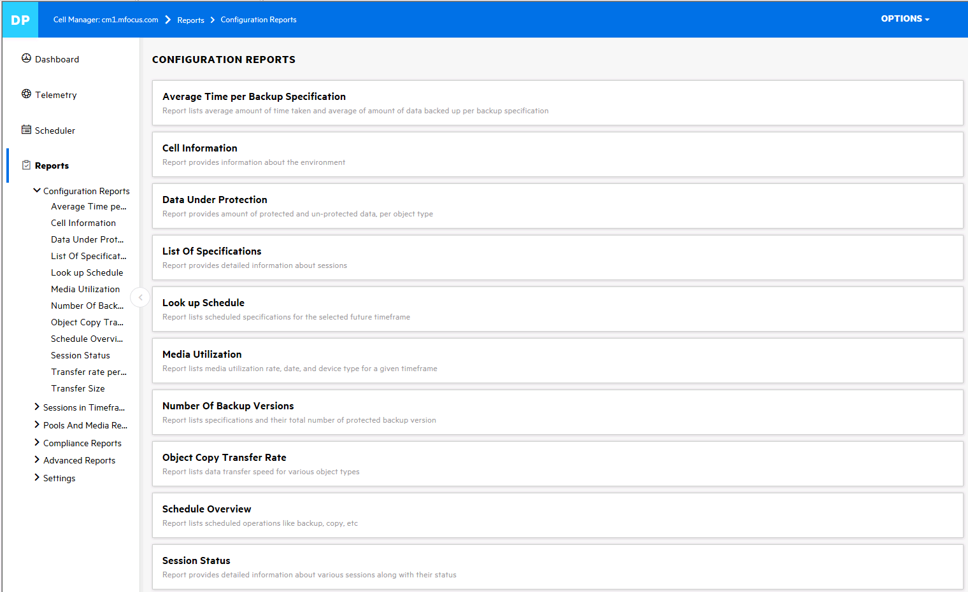

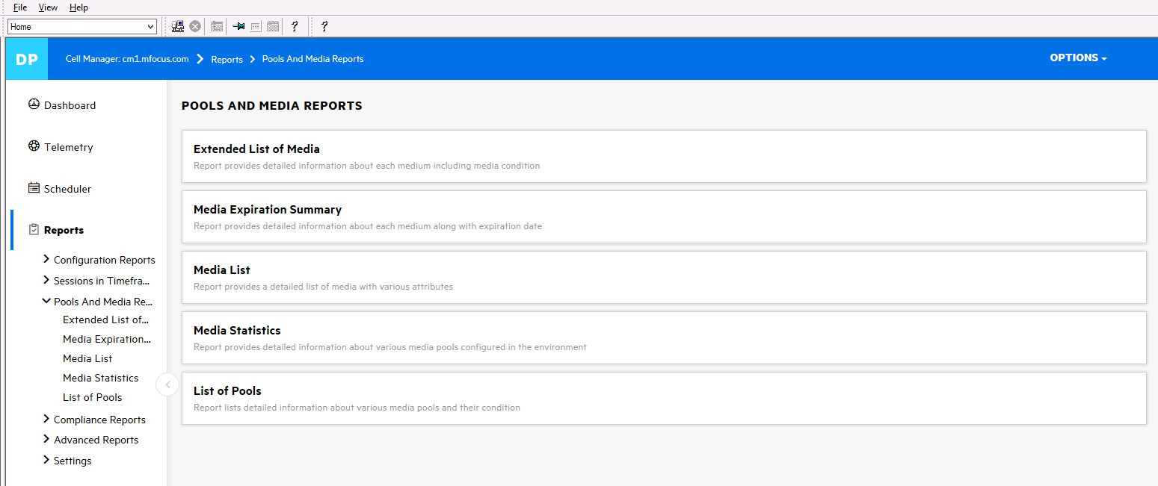

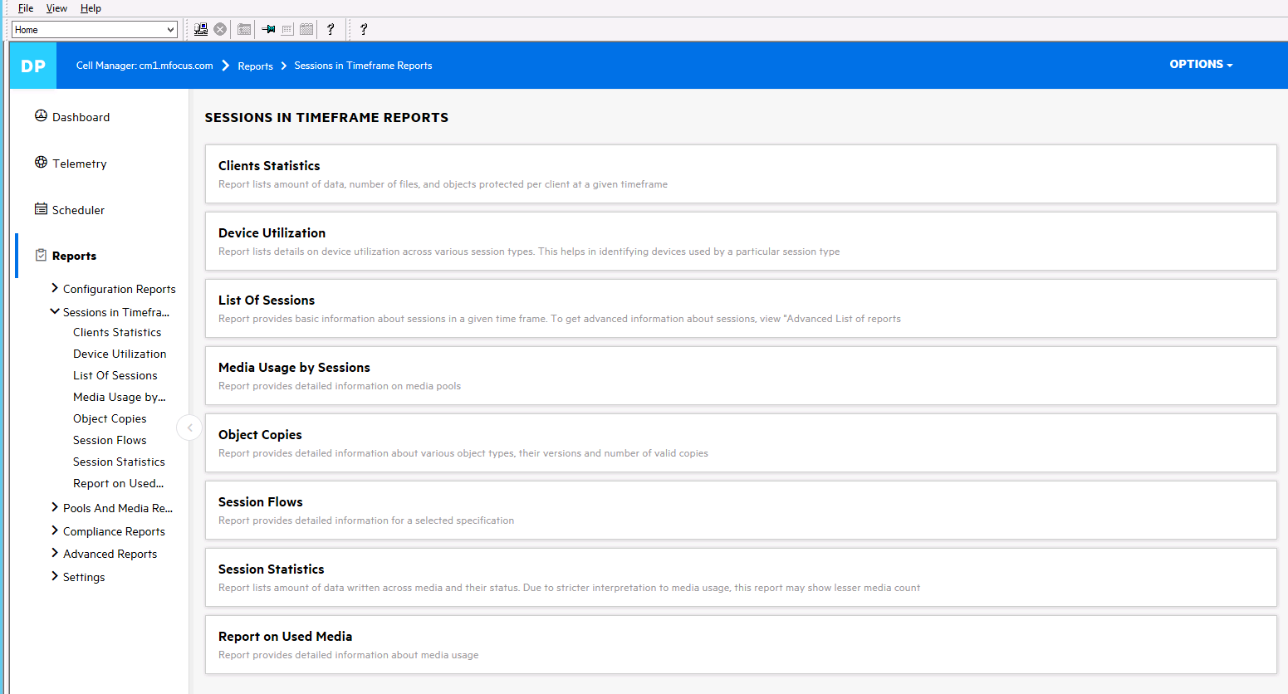

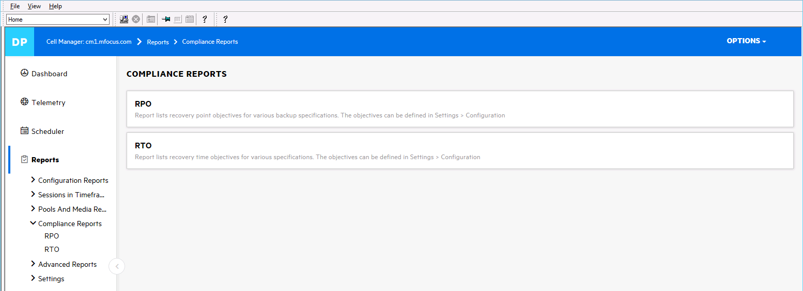

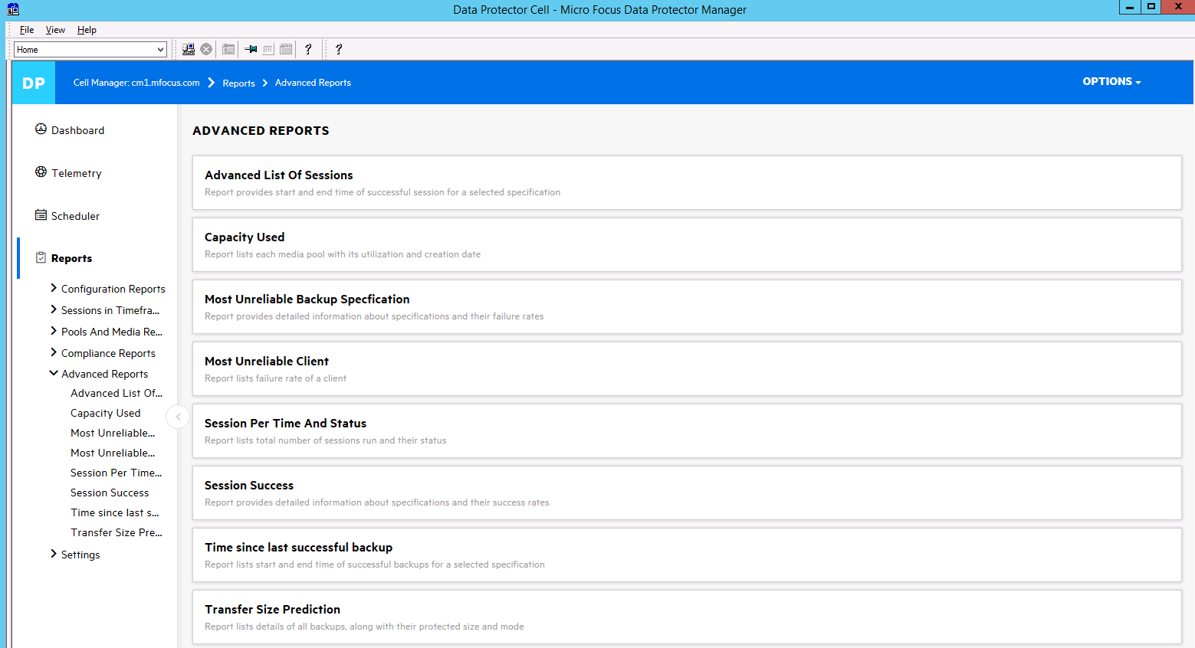

You will want to demonstrate some of the more useful reports, such as:

* Data Under Protection
* List Of Specifications
* Media Utilization
* Session Status
* Transfer Size
* Device Utilization
* RTO/RPO Compliance
* Capacity Used
* Sessions Per Time and Status

# Section 7. The Advanced Scheduler

Let’s now return to scheduling. Select the “Home” Context.

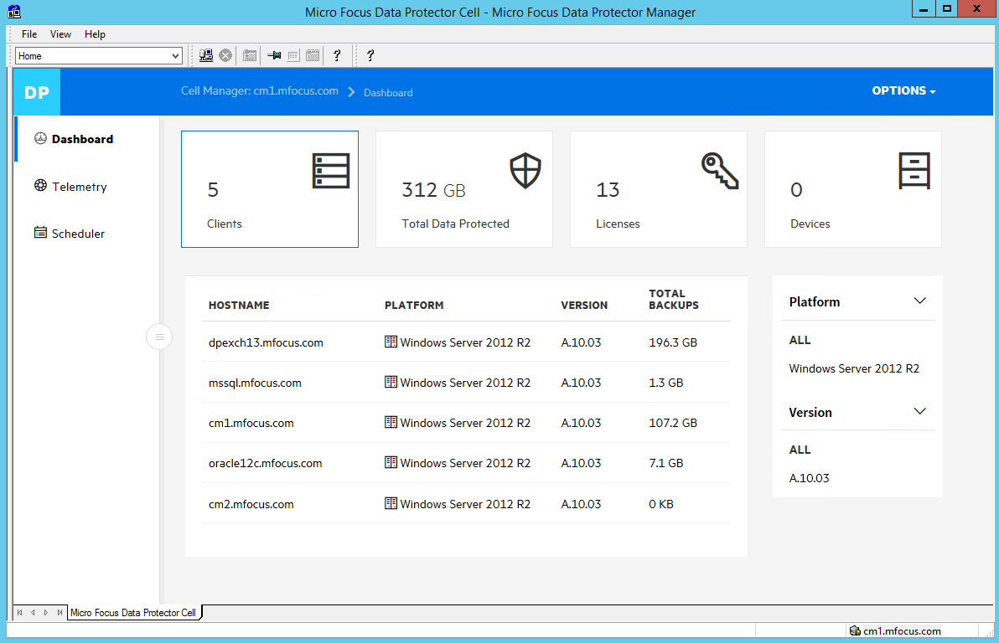

Now select “Scheduler” on the left

You will now see something like this:

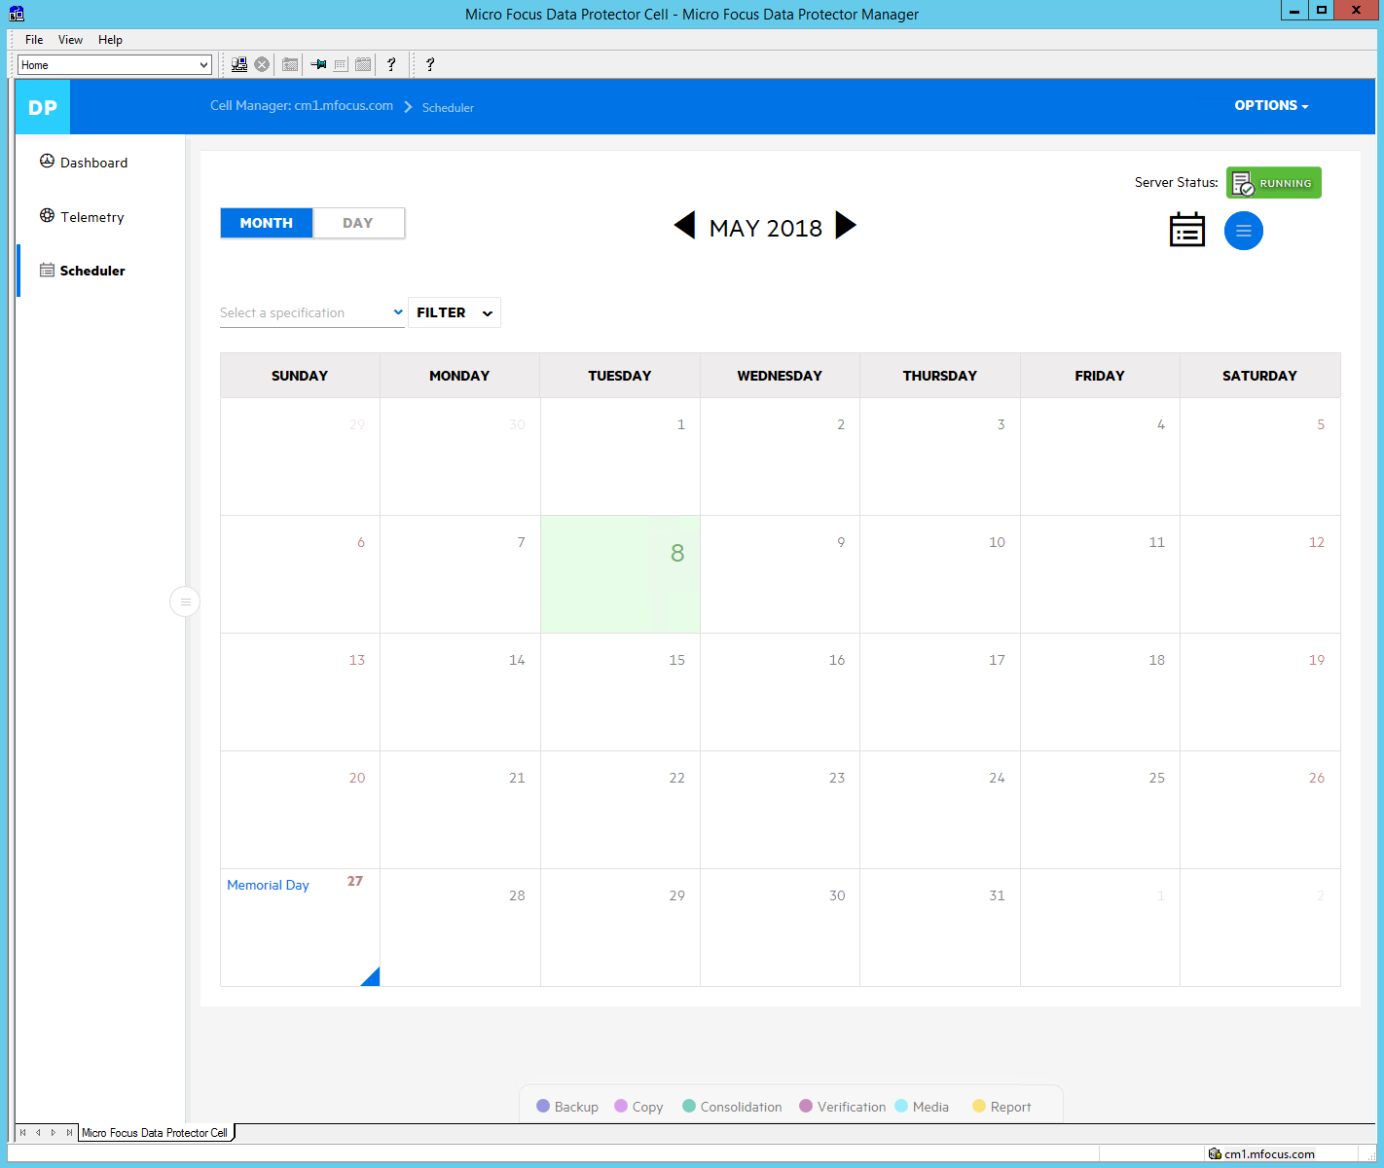

Click on the day today is (it will be different than this picture…) and you will see this:

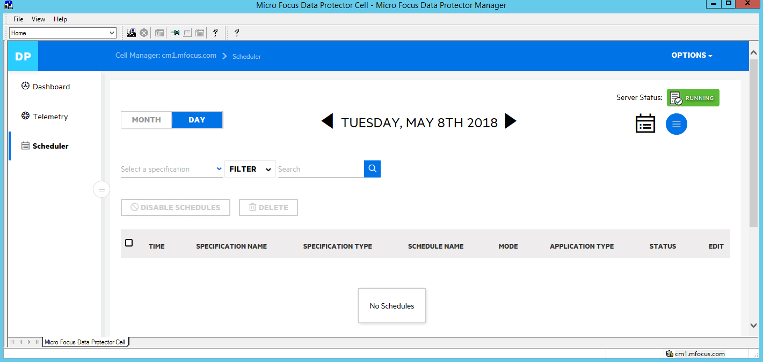

Now press the “triple bar blue circle”

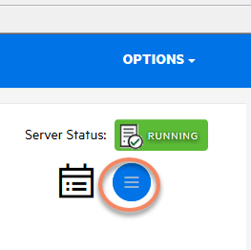

and see this:



Click the “+” sign, and see this:

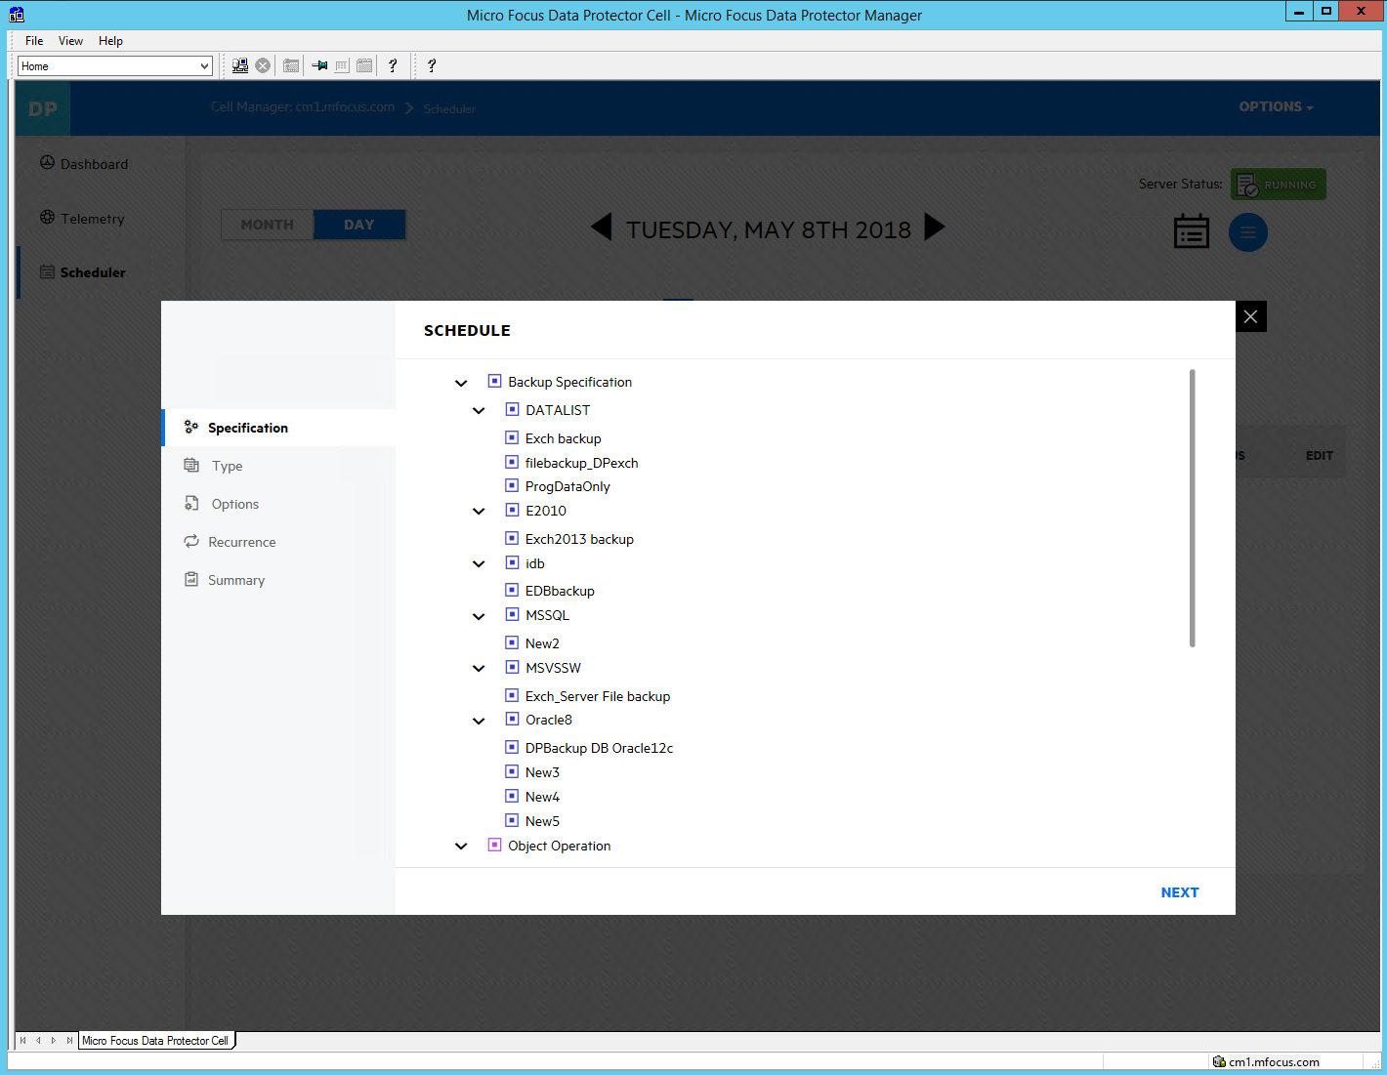

Note that the Backup Specifications have already been created in the “Classic” GUI- you can verify by going back to the “Backup” context in the Classic GUI. In this case, we’ll use ProgDataOnly.

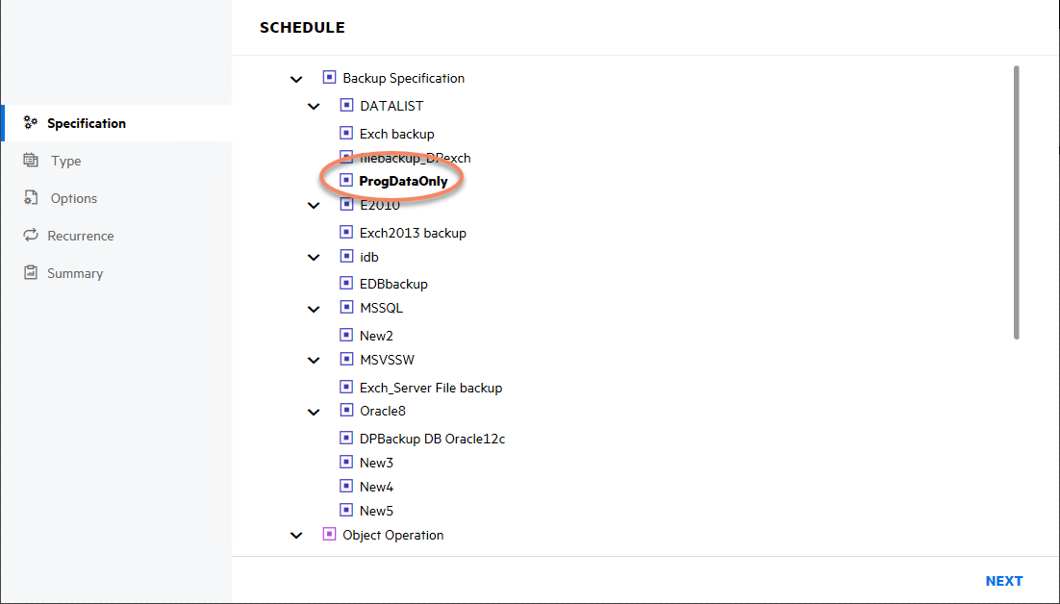

Hit “NEXT”. Let’s pick “Predefined, Daily Full”:

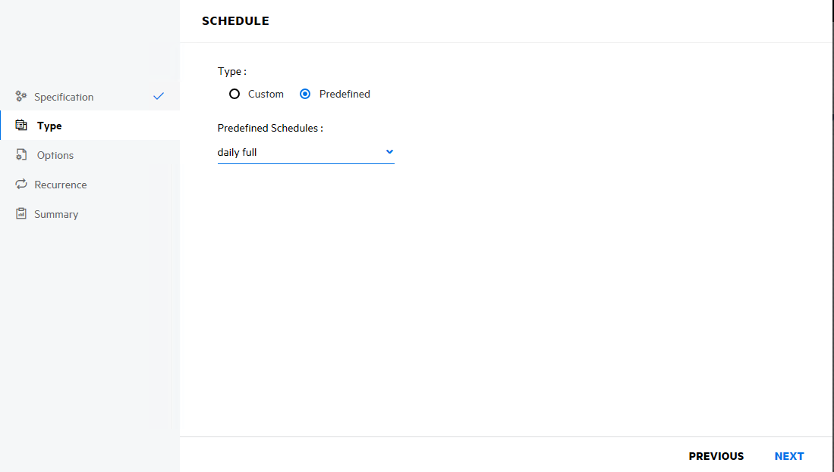

Hit “Next”. Enter a Schedule Name. We’ve used “Filesystem Daily Full” as the name, you can choose your own if you’d like.

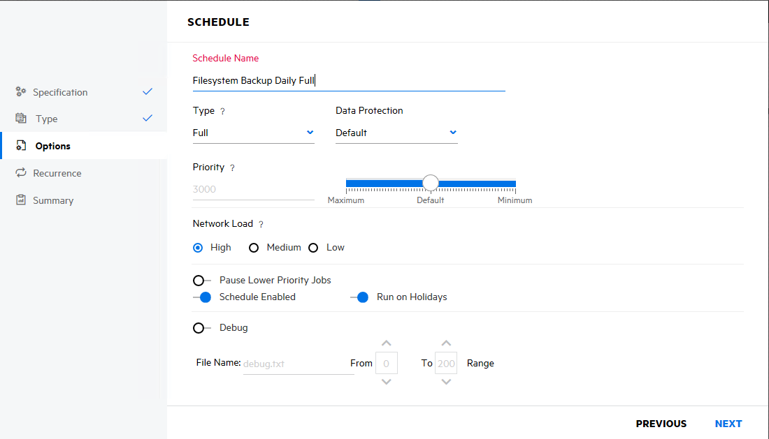

Hit “NEXT”. Now we pick “recurrence”:

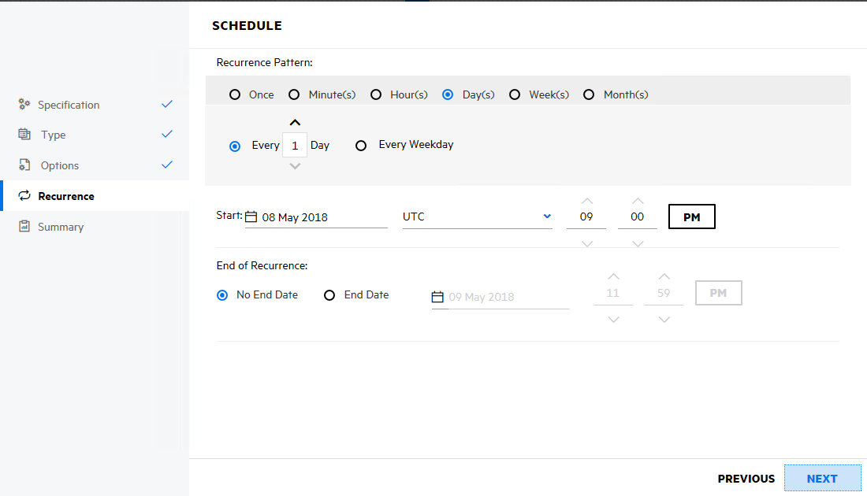

You can pick any start date you want. By default it chooses today’s date, whatever that is when you perform this lab.

Next, you will get a summary:

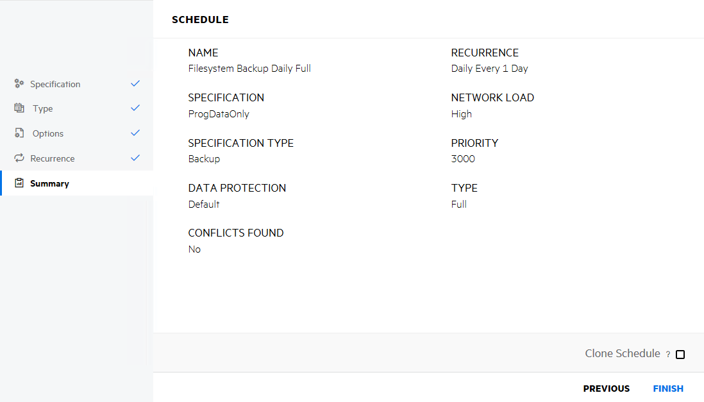

Then hit “FINISH” and you will see this:

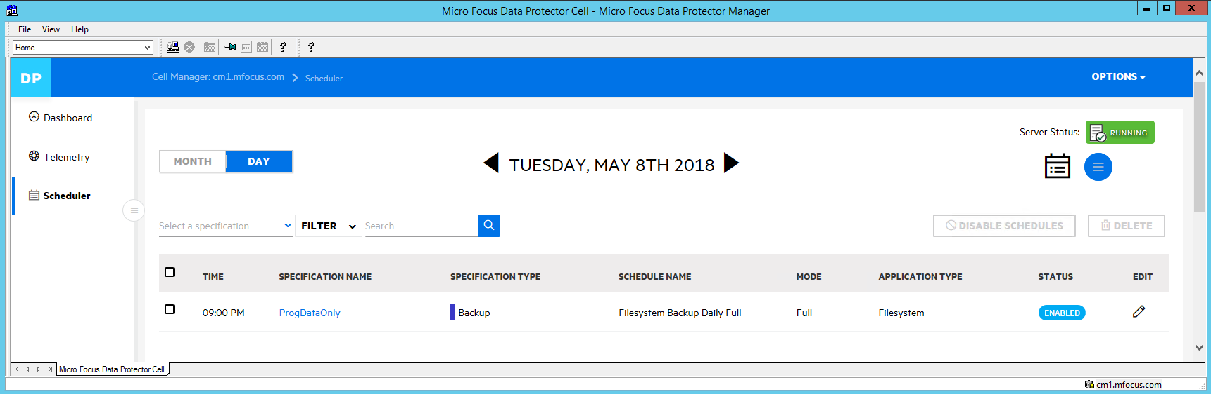

The “Blue” Bar and the Specification Type “Backup” tell you what kind of operation it is. The specification name and the schedule name are also shown here.

You will now see when returning to the “MONTH” view:

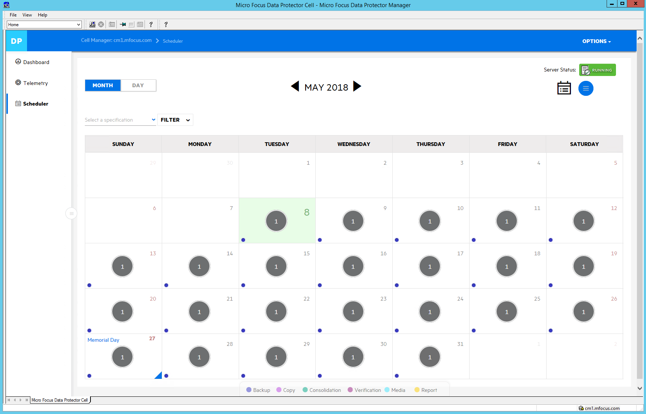

You will see that regardless of the date you look at in the calendar, this job shows up on EACH day on and after January 18, 2018. It will stay this way until changed or deleted.

If time permits you may come back and set up other schedules, and delete schedules, but please don’t run any other Specs other than “ProgDataOnly”. The back-end StoreOnce repositories are SHARED and thus may fill up if large backups are scheduled on a repeated basis.

This concludes the section on the Advanced Scheduler.

# Section 8. ARS- Automated Replication Synchronization

Here are the concepts of ARS:

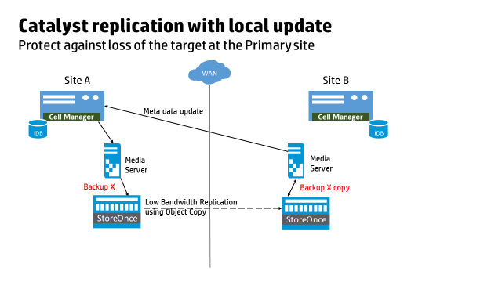

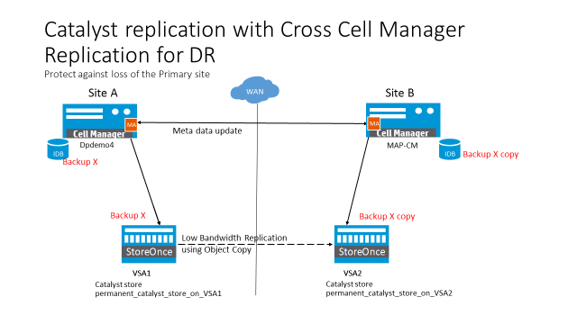

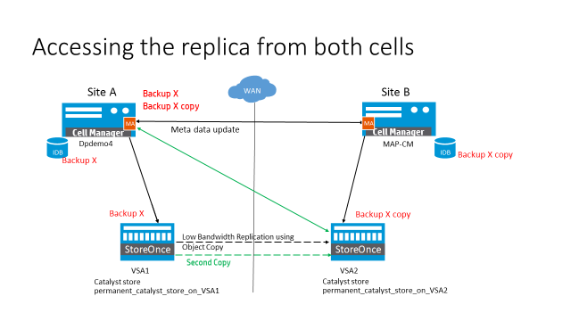

Automated Replication Synchronization

The Data Protector replication feature enables you to replicate objects between two Backup to Disk (B2D) devices that are capable of replication, without transferring data through the Media Agents

. The Cross Cell Manager  Replication feature is an extension of the normal replication, which allows you to replicate backup metadata between two deduplication appliances that are managed by different Cell Managers. This feature allows you to easily exchange backup data and other metadata between two deduplication devices.

Prerequisites

Ensure that the Data Protector user (under whose account the CRS  is running) on the source Cell Manager has access to the target Cell Manager, and vice versa.

Limitations

Consider all the limitations that apply to the normal replication feature.

The target Cell Manager should have the same or newer version as that of the source Cell Manager.

The devices in the source Cell Manager and the foreign Cell Manager, which are selected for replication, must point to the same physical device  and datastore.

If the source and foreign Cell Managers use Encrypted Control Communication, ensure that Trust Relationship is enabled. For more information on establishing trust, see Enabling encrypted control communication for all cells in a MoM environment, using the CLI.

The maximum number of media that can be replicated at once depends on the available free connections on the target device . For instance, if the target device has 100 free connections, it is recommended that not more than 100 media be replicated at the same time. Also, if you

want to use the target device for other operations, the number of media that can be replicated at the same time must be fewer than the available free connections. For StoreOnce and Data Domain Boost devices, check the available data connections and replication streams respectively. For more information on the supported streams, see the respective device manuals.

Cross Cell Replication list using an older GUI is not supported. You may see the following error message: "Error parsing Copy Specification file. The file may be corrupted or invalid." This message indicates the Data Protector GUI from older versions does not support the new list.

The Include only objects with number of copies less than option is not supported for the Cross Cell Manager Replication procedure.

Cross Cell Manager Replication involves two procedures:

Importing the foreign Cell Manager

Performing an Object Copy session

Note: You will be using your assigned StoreOnce VSA as the source and VSA #6 as your target.

Cell Manager 2 (CM2) will be the “foreign” cell manager for the purposes of the demo.

Importing the foreign Cell Manager

The first step in triggering the cross Cell Manager replication is to import the foreign Cell Manager into the source Cell Manager. To import the foreign Cell Manager:

In the Context List, click Clients.

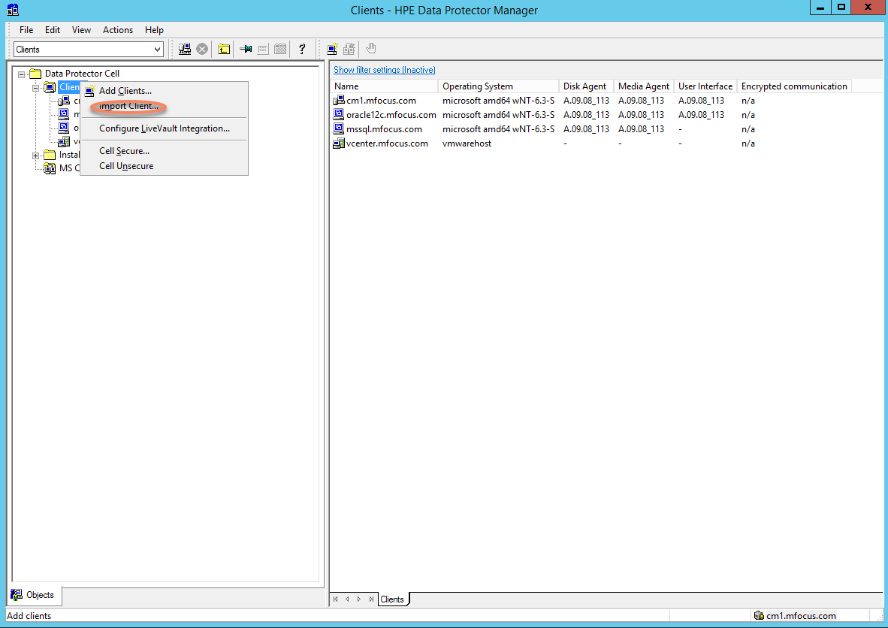

In the Scoping Pane, right-click Clients and click Import Client.

Type the name of the client  or browse the network to select the client (on Windows GUI only) that you want to import. If you are importing a Cell Manager that manages a deduplication appliance, select Data Protector Foreign Cell Manager

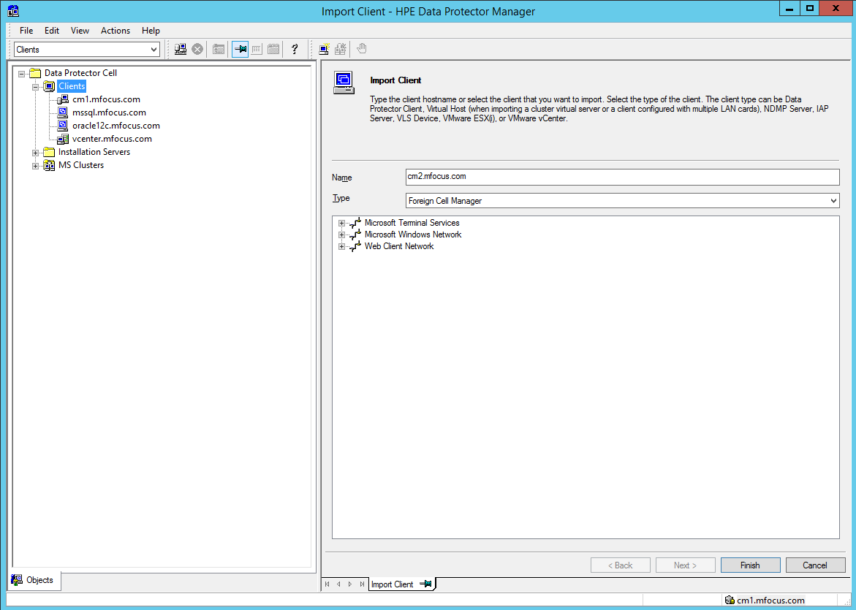

**Note**: The above step is relevant if you are performing a cross Cell Manager replication procedure.

Click Finish to import the client.

The name of the imported client is displayed in the results area.

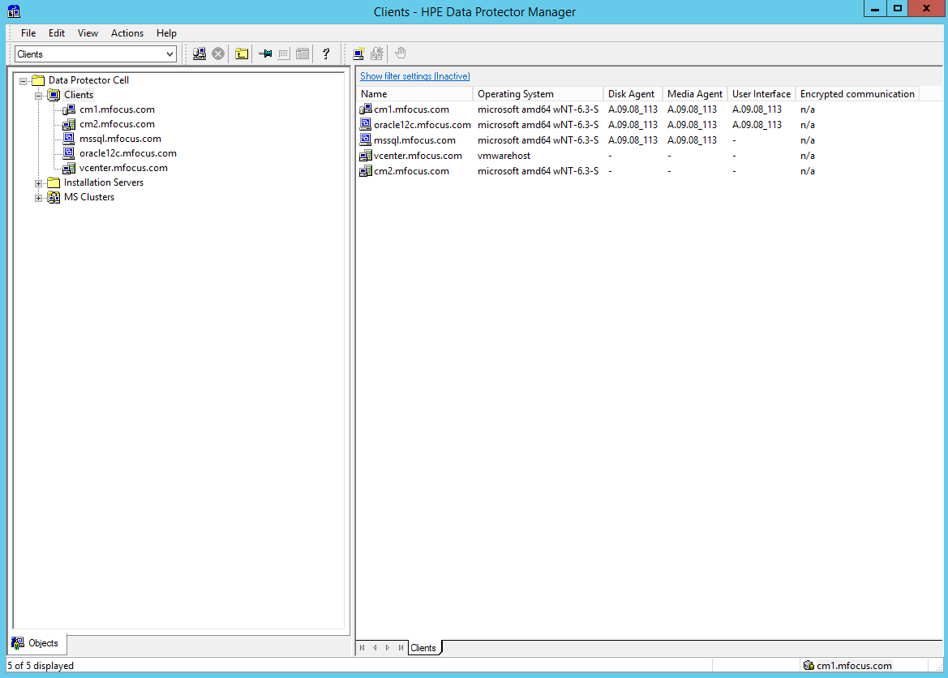

**Note**: You can perform only the Cross Cell Manager Replication action on the imported cell  manager. You will not be able to perform any other operation using the cell manager.

Performing an Object Copy session

After you import the foreign Cell Manager to the source Cell Manager, you can perform an Object Copy session to copy the backup data and other metadata into the source Cell Manager. To perform an Object Copy session:

In the Context List, click Object Operations.

In the Scoping Pane, navigate to Copy > Object copy > Automated.

Right-click Scheduled and click Add to open the wizard.

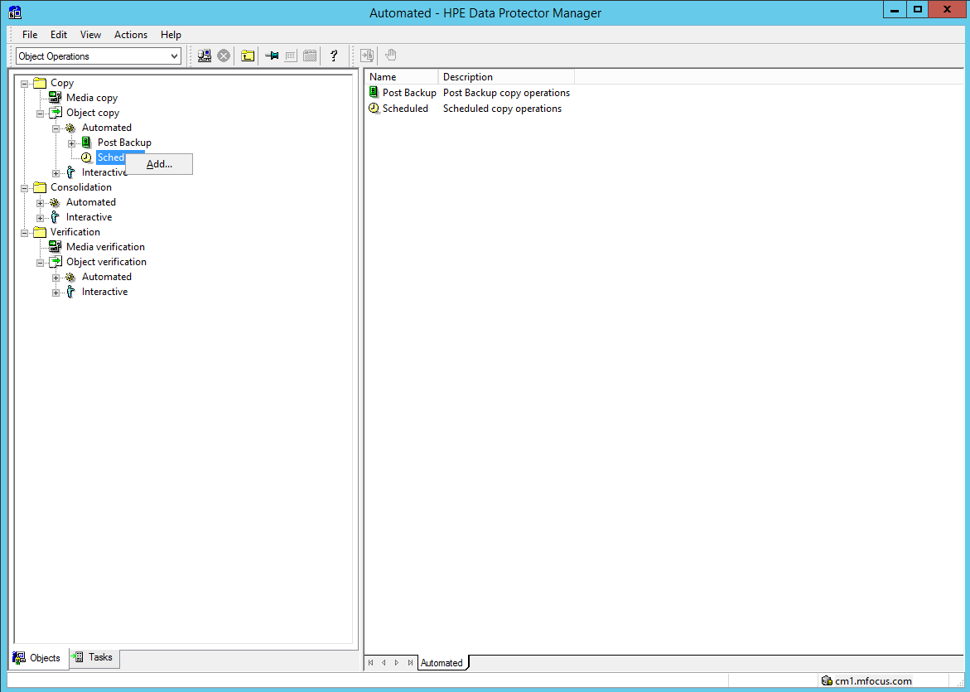

Select the backup, object copy , or object consolidation  specifications that contain the objects you want to copy. Click Next.

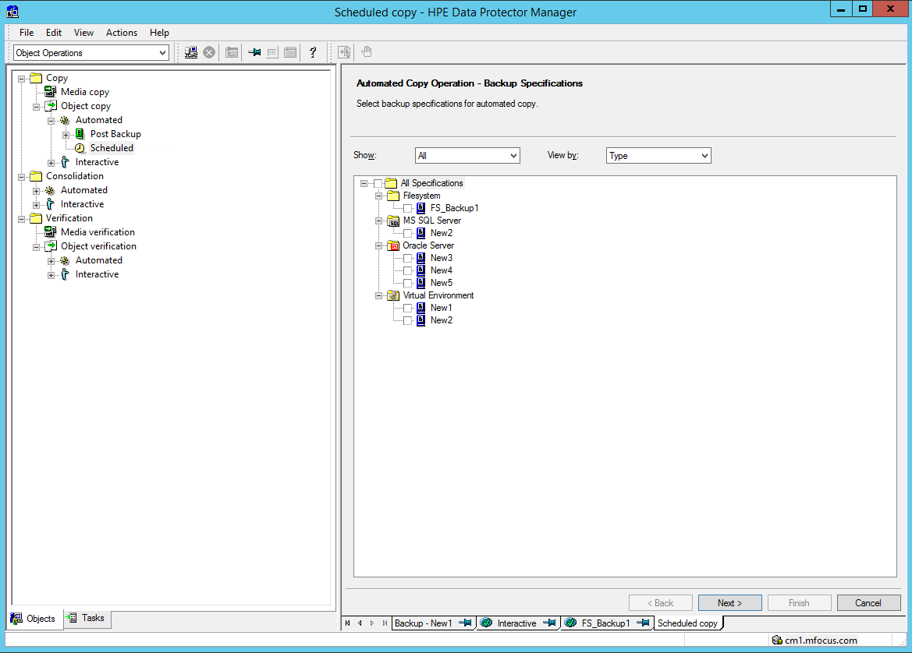

Specify the object  filter for the object copy operation. Only objects that match the specified criteria will be copied. Click Next.

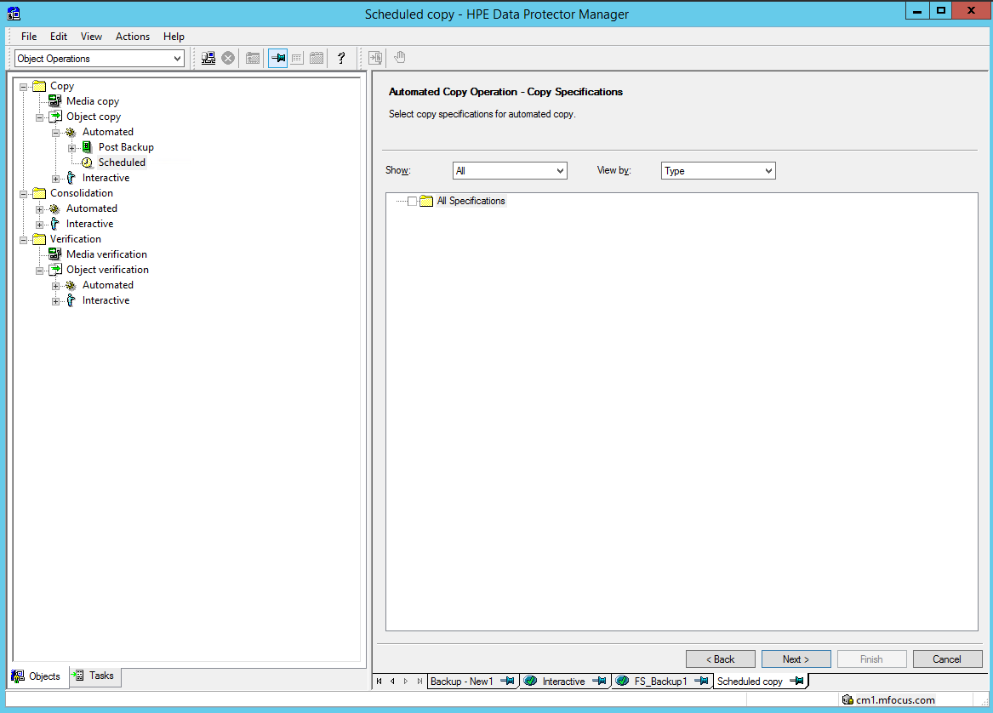

Specify the library  filter for the object copy operation. Only objects residing on media in the specified libraries  will be copied. Click Next.

The devices that are used for backup in the selected backup specifications are used as source devices in the object copy operation by default. You can change the source devices here if desired. Click Next.

Select the destination devices  for the object copy operation. Data Protector will select the most suitable devices from those you specify here. Click Next.

Select the Show Capable of replication check box to select only those devices that have backup to disk (deduplication) devices. Replication is possible only on Backup to Disk devices.

Specify the source object options, target object options, and target media  options as desired.

Select Use replication to enable replication between two B2D devices instead of copying.

Select Replicate to foreign cell to enable replication of objects to the foreign cell server that you imported earlier (This Cell Manager contains the second deduplication device).

Click Next.

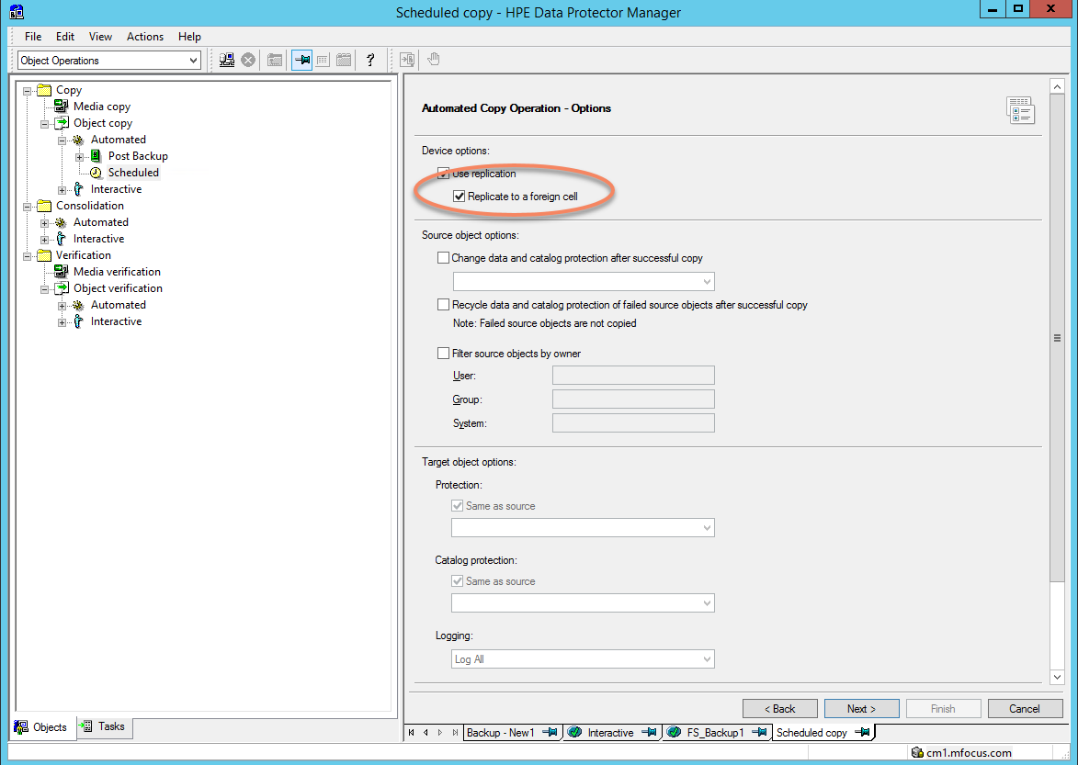

Select the foreign cell server that you imported earlier from the drop down menu. This lists the devices that are linked to the backup to disk store.

All the devices that are created from the target cell manager, and having the same store name are displayed here. Therefore, ensure that you select the device having the correct store name for replication.

Select the required device or gateway and click Next.

Right-click a date and click Schedule to display the Schedule Copy dialog box. Specify the options as desired and click OK. Click Next.

Click Save as..., enter a specification name and click OK to save the scheduled object copy specification.

Run the scheduled object copy session  to complete the Cross Cell Manager Replication procedure.

The following screen shot from the StoreOnce VSA shows the replication between the source and destination. This includes all catalog information on the backup so that the destination can be brought up immediately in case of a disaster at the source site.

